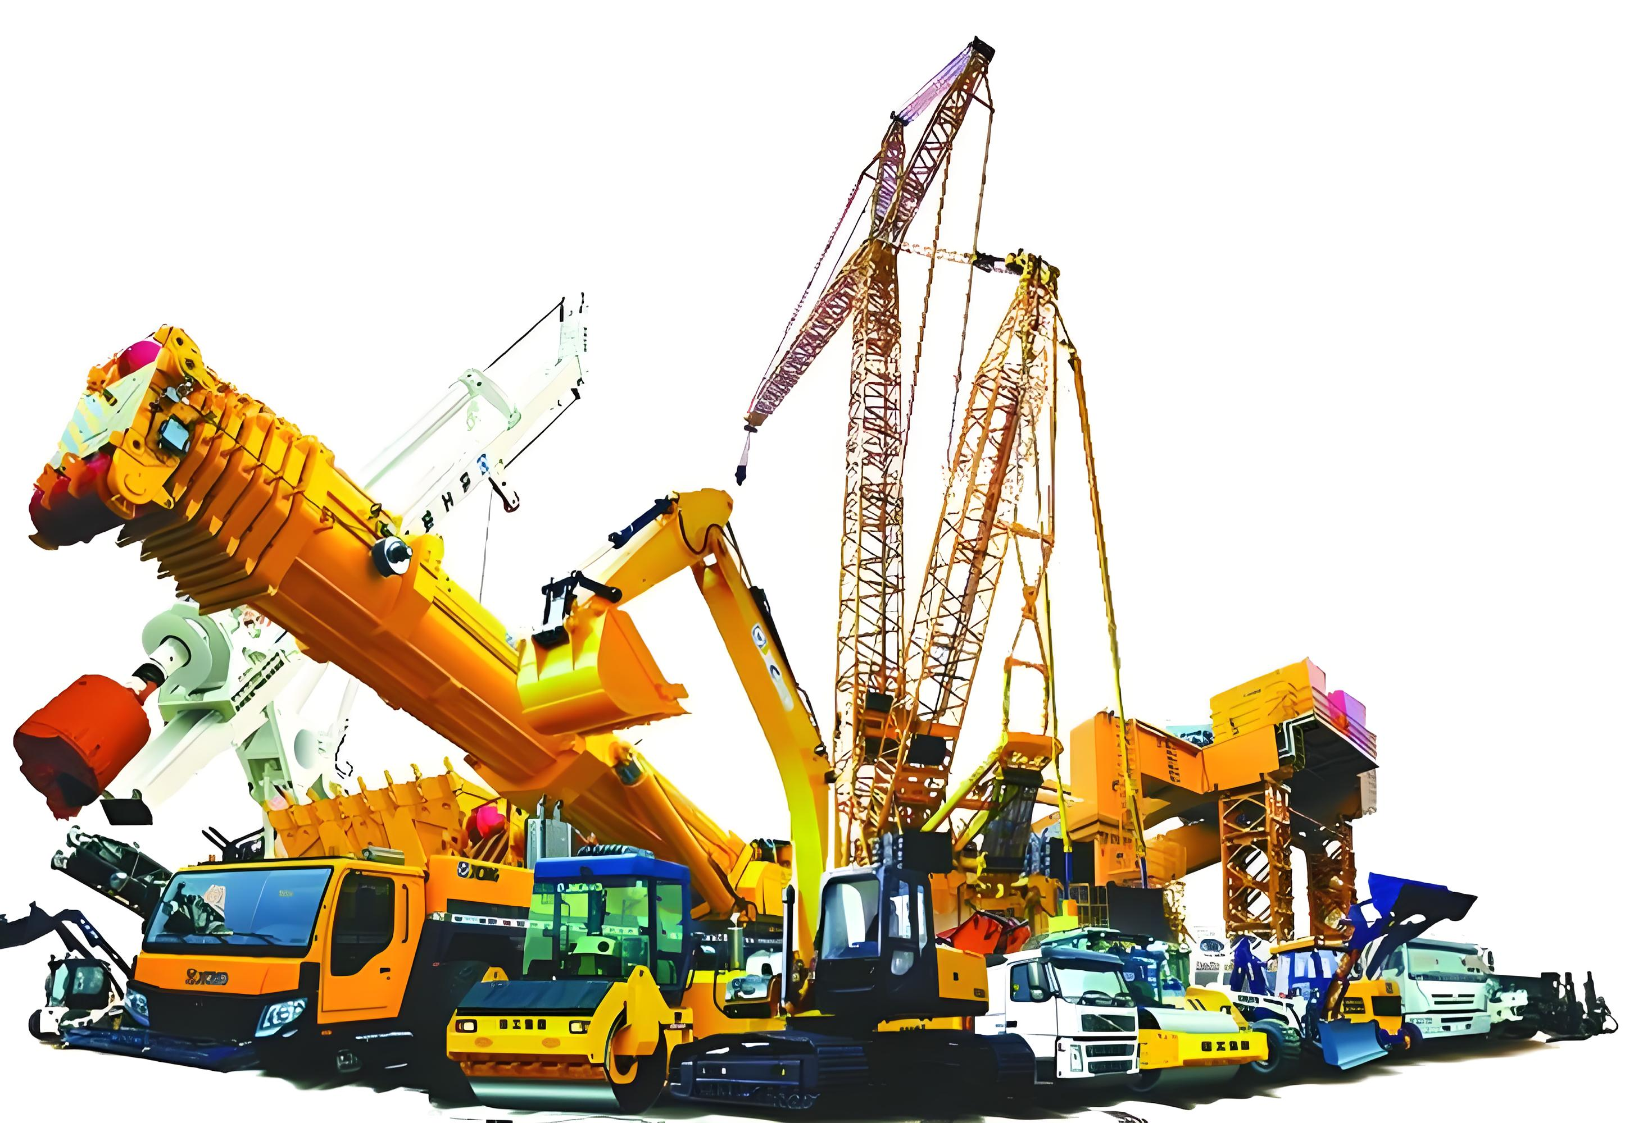

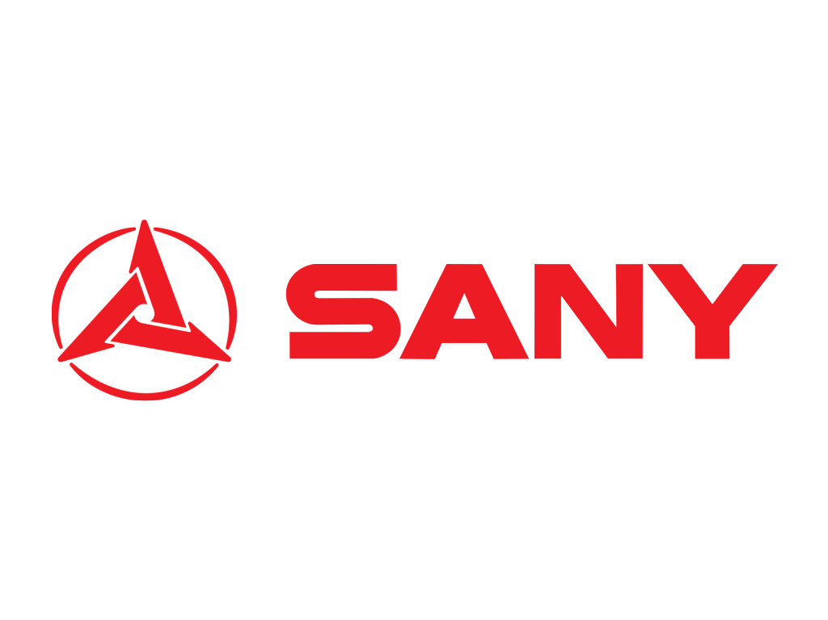
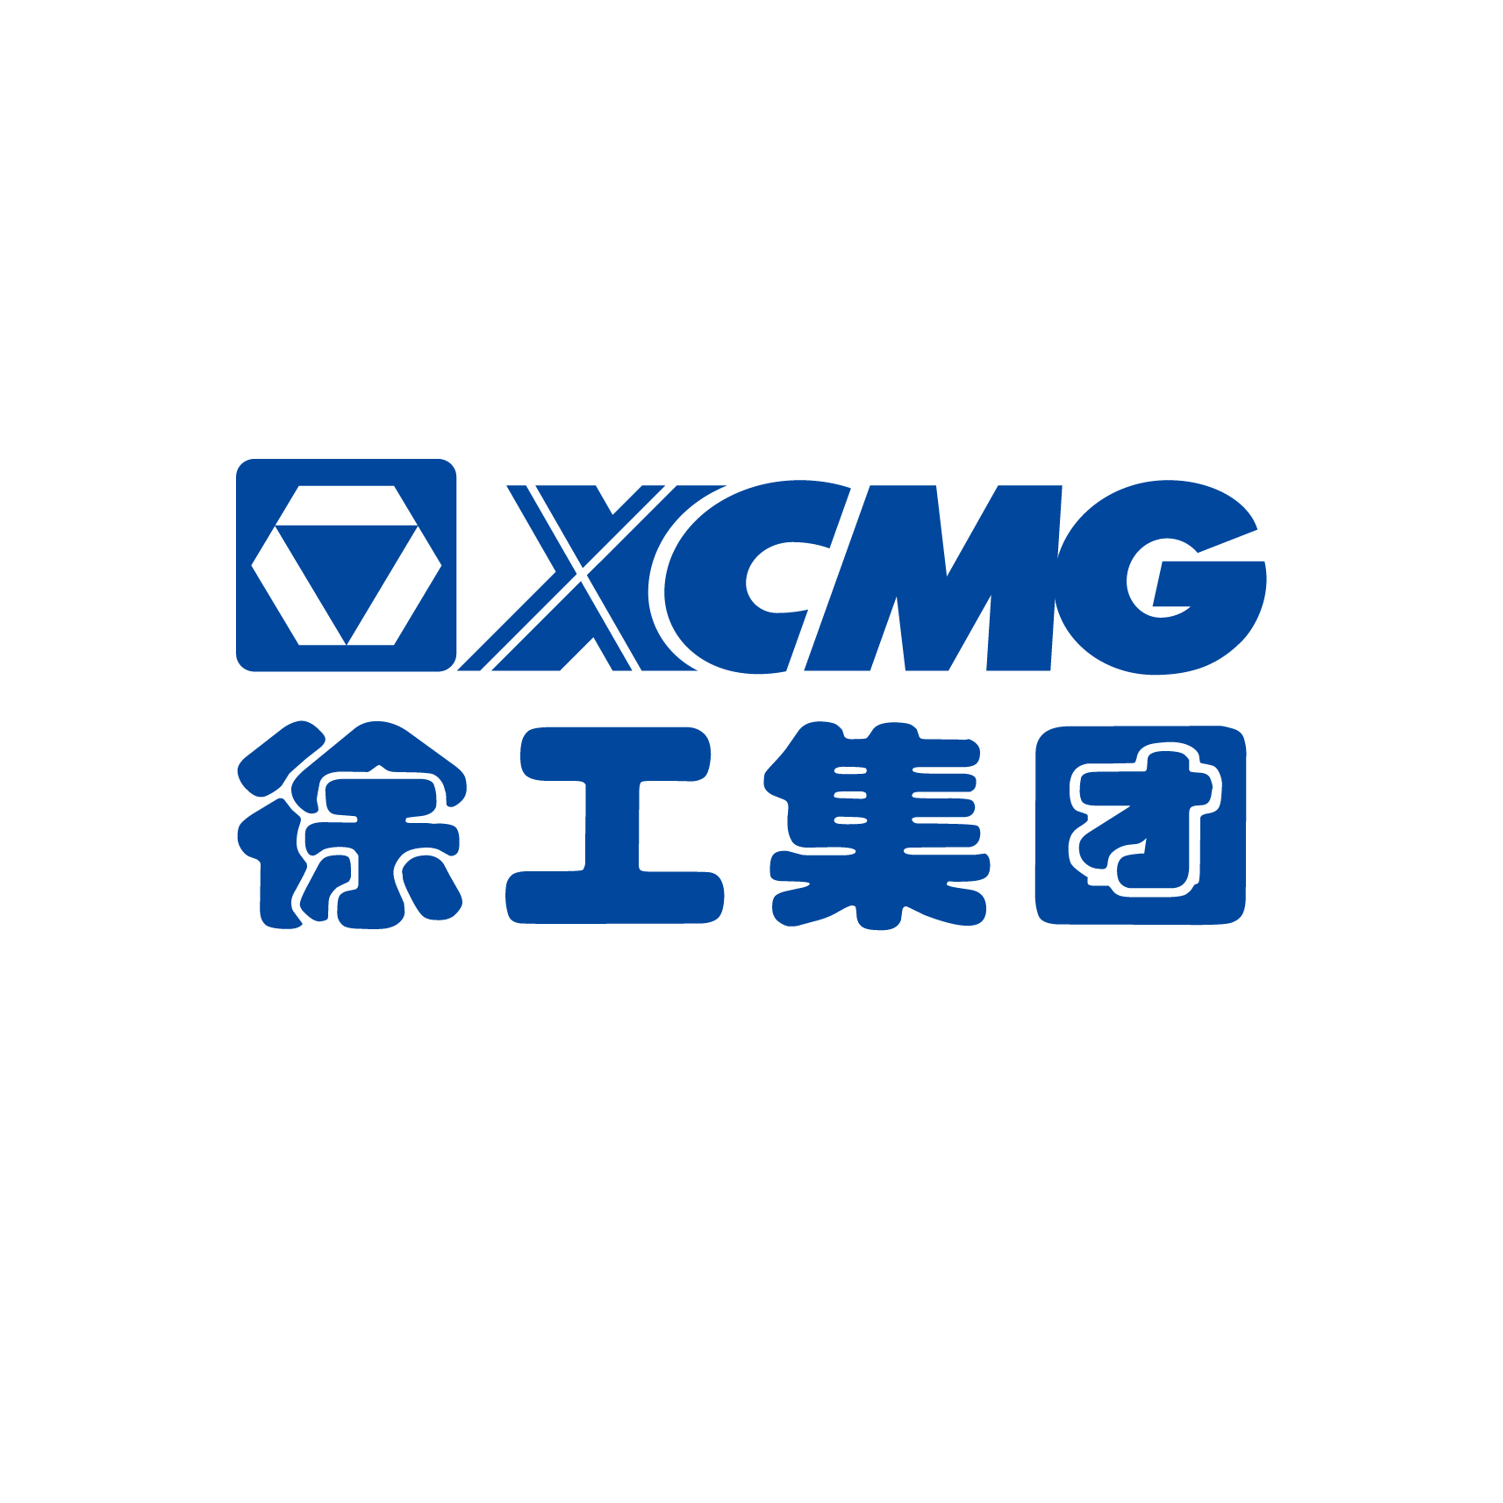
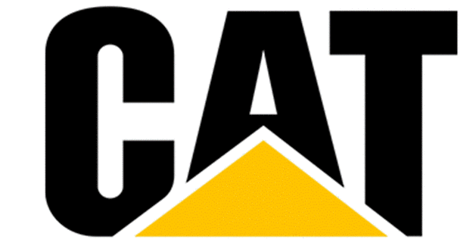




XCMG Sany Zoomlion Partner
Used Machinery·Spare Parts·Remanufacturing
Provider
Changsha Betalift Machinery Technology Co.,Ltd
Betalift Machinery
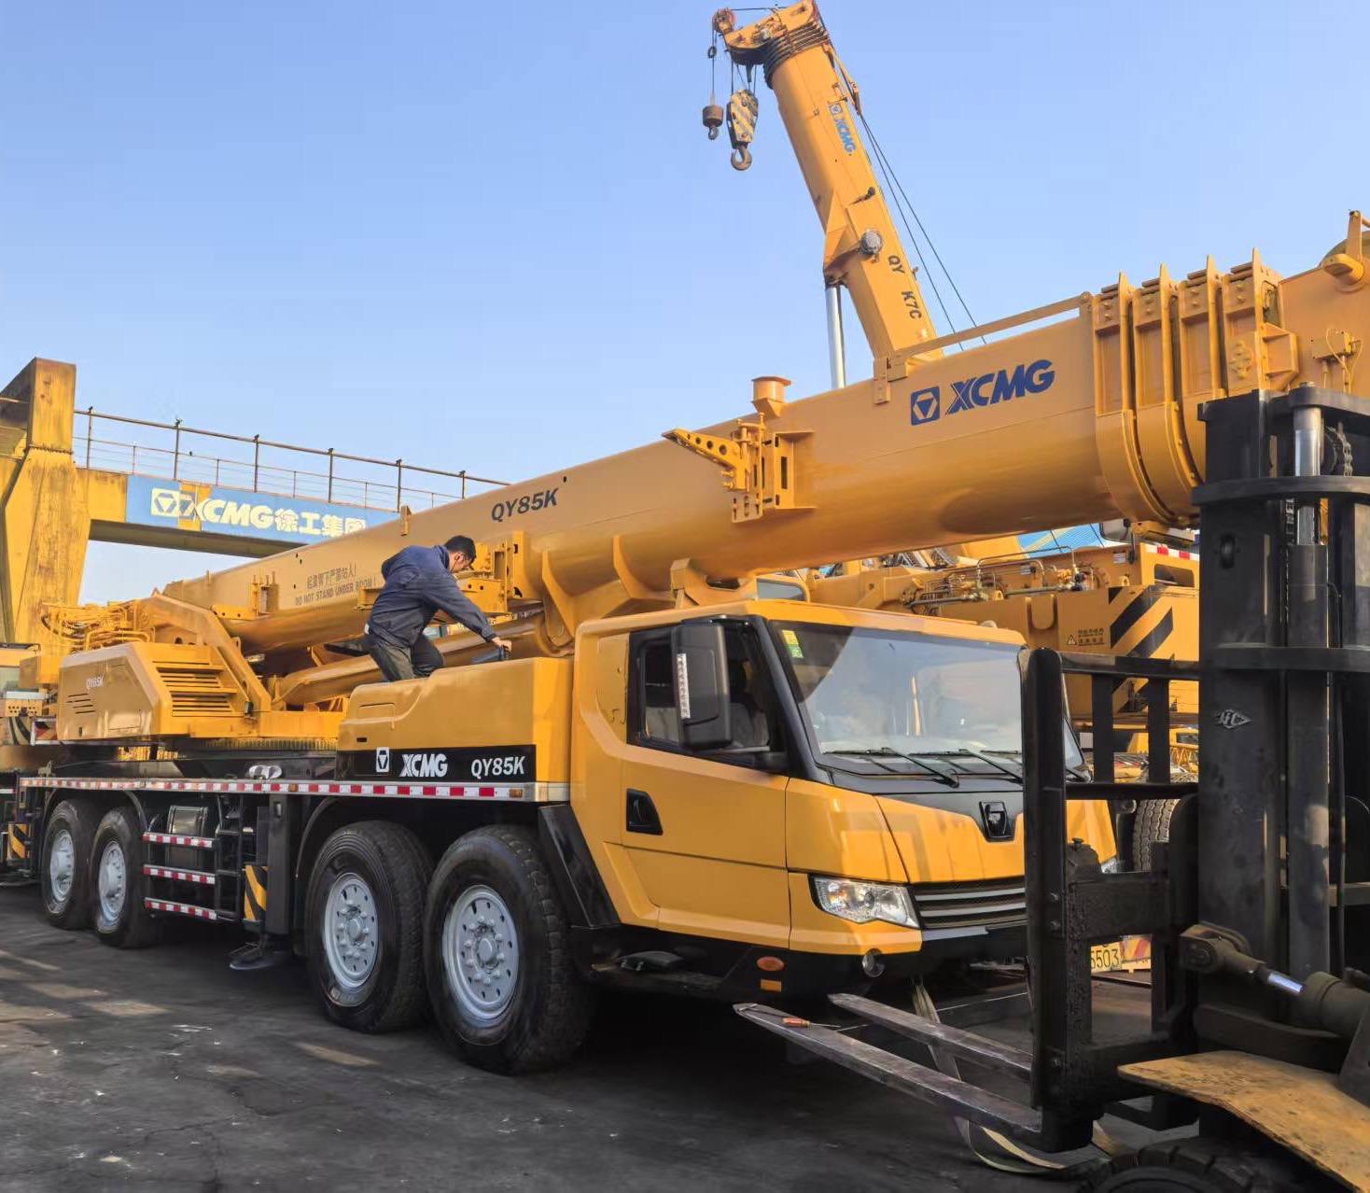
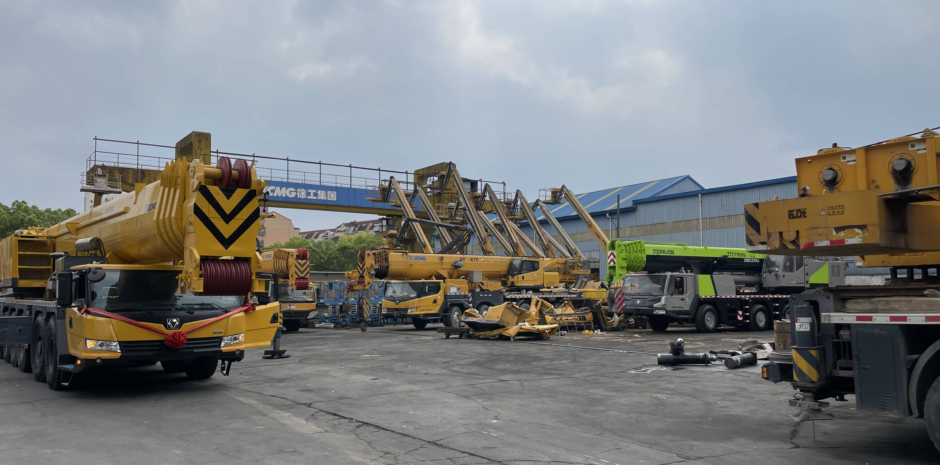
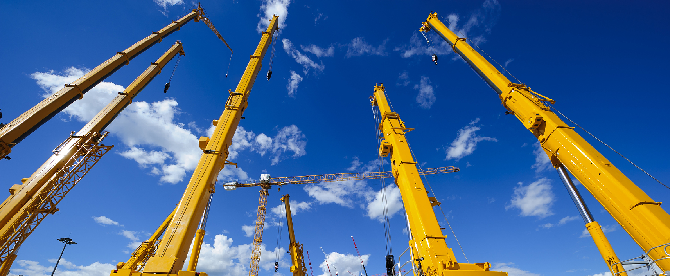

• Extensive Industry Experience – Years of experience in the used construction machinery market.
• Wide Product Range – A full lineup of reliable machines and equipment to meet various construction needs.
• Professional Technical Support – Skilled technicians provide expert guidance and maintenance solutions.
• Genuine Spare Parts – Fast and reliable supply of original or high-quality compatible parts.
• Flexible Solutions – Customized services based on customer requirements, including sourcing and logistics.
• Global Reach – Capability to serve domestic and international clients with efficient delivery and support.
Enterprise Advantage
Changsha Betalift Machinery Technology Co., Ltd., was founded in 2011 in Changsha, China, the same city as the headquarters of Zoomlion and Sany. It has grown to become one of the largest Chinese enterprises specializing in the export of used heavy machinery. Betalift led the way in completing the initial export of used mobile cranes in China and ranked Top 3 in total annual export volume.
Our company specializes in the trade of used construction machinery, offering a comprehensive range of services including equipment sales, spare parts supply, and professional technical support. Our product lineup includes truck cranes, crawler cranes, aerial work platforms, excavators, rotary drilling rigs, bulldozers, concrete pump trucks, and more. We are committed to providing reliable equipment and expert solutions to meet the diverse needs of our customers.
Enterprise Profile
www.betalifting.com

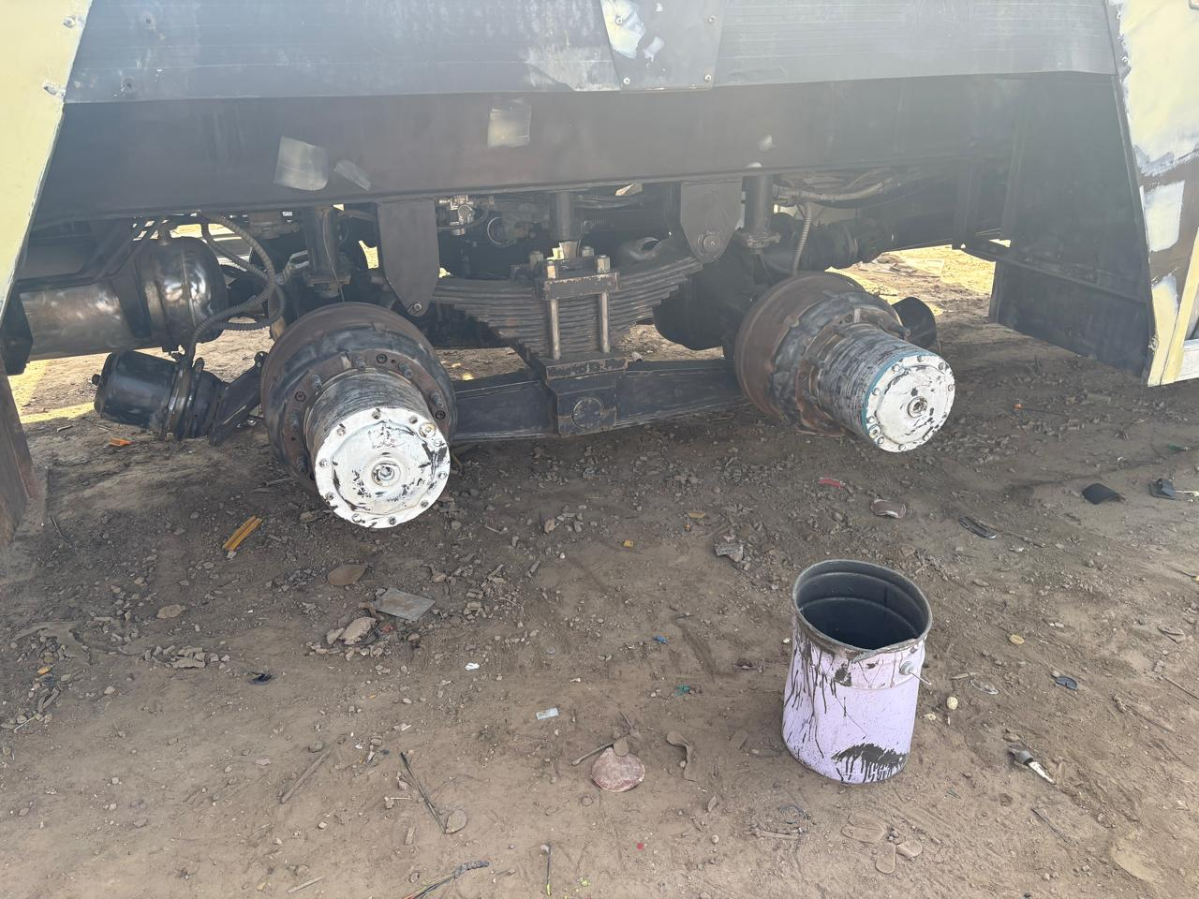
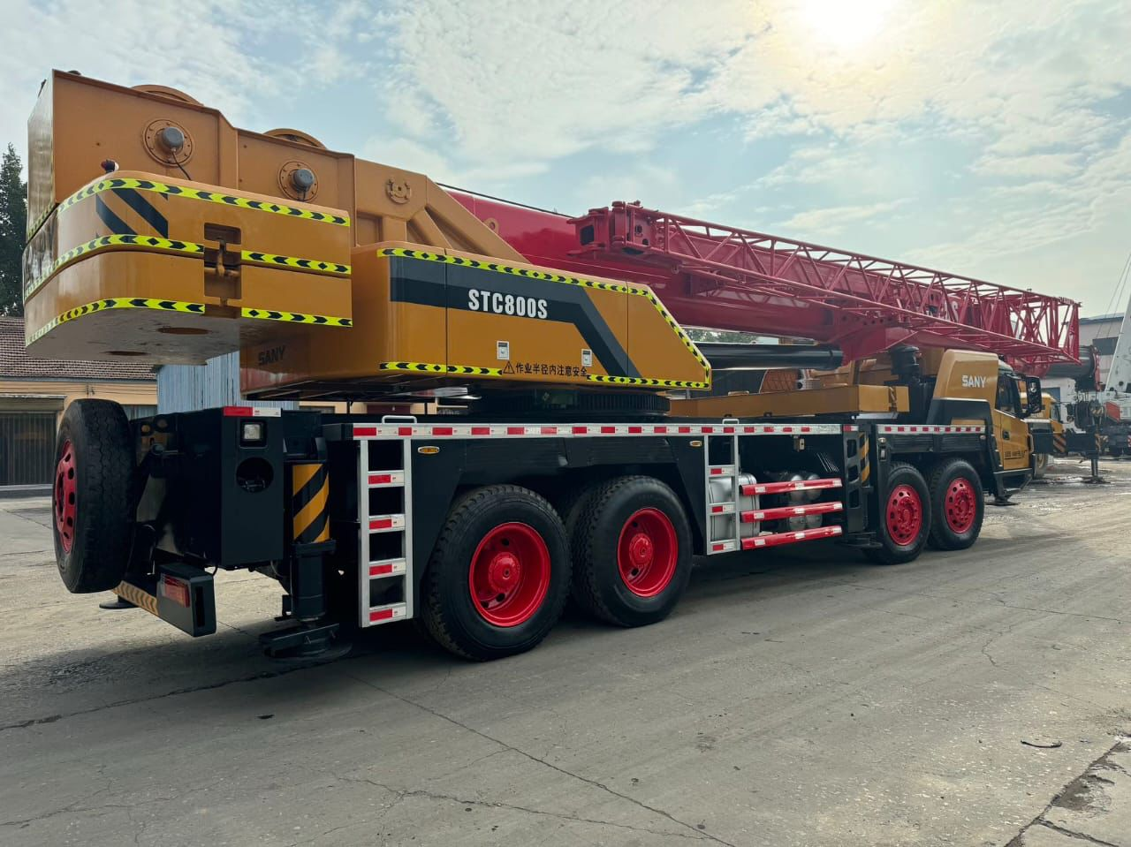
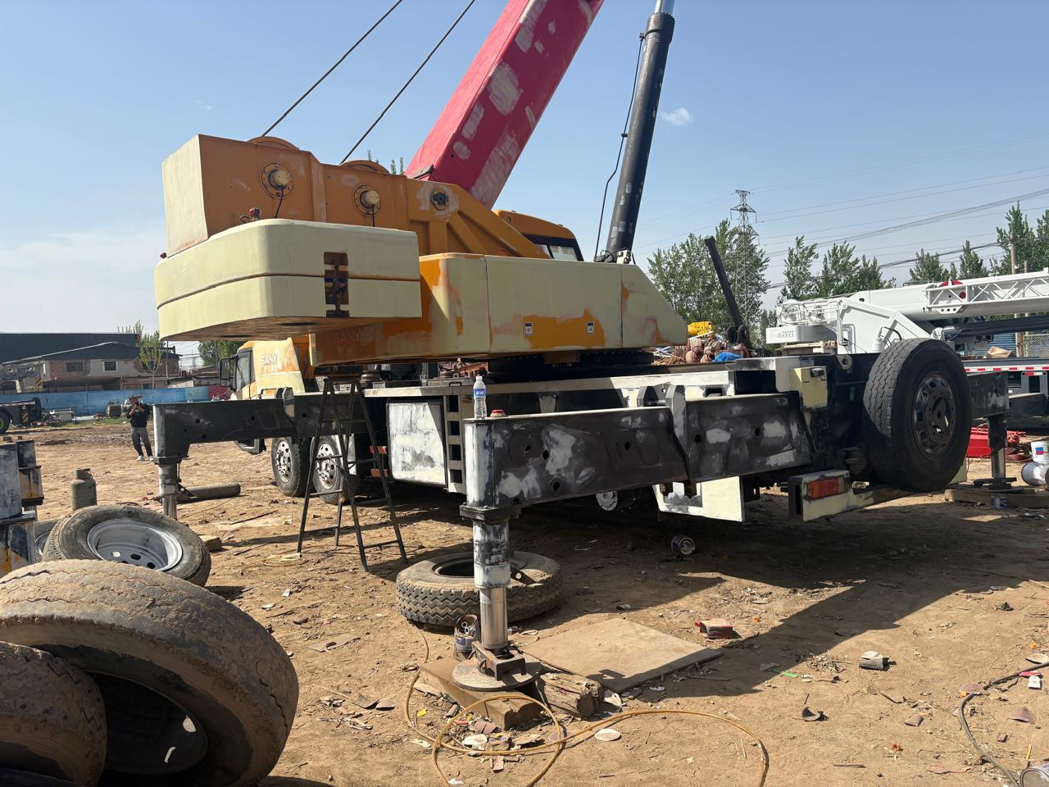
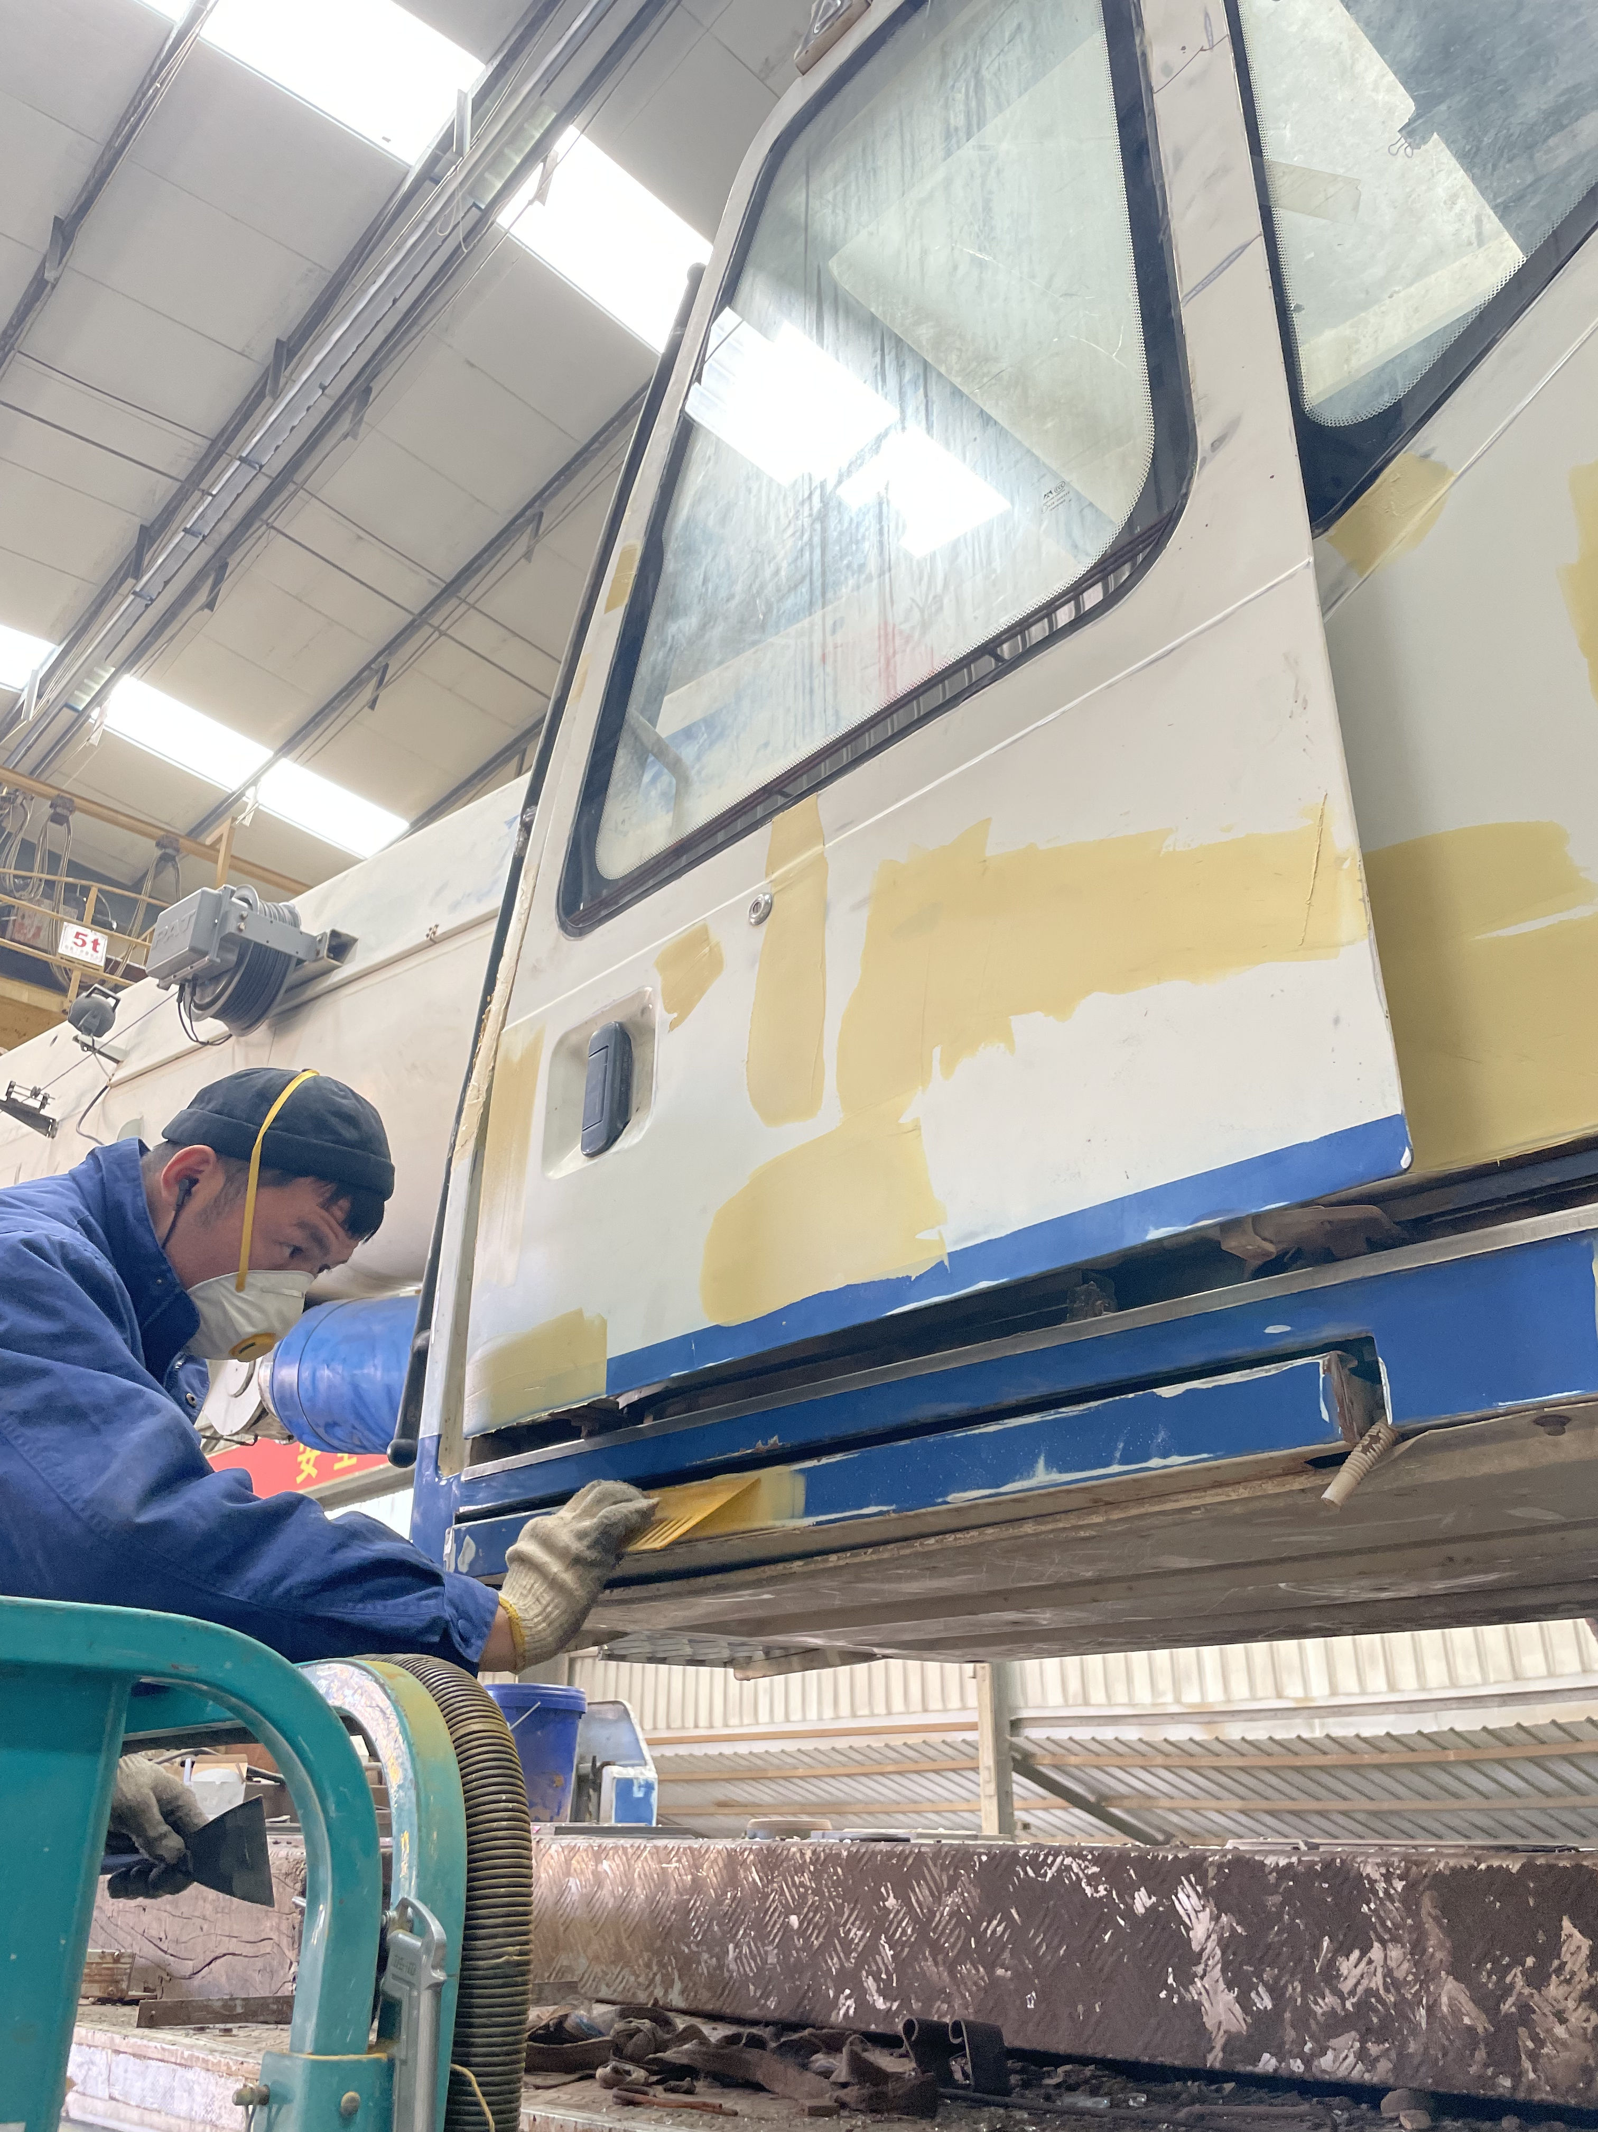
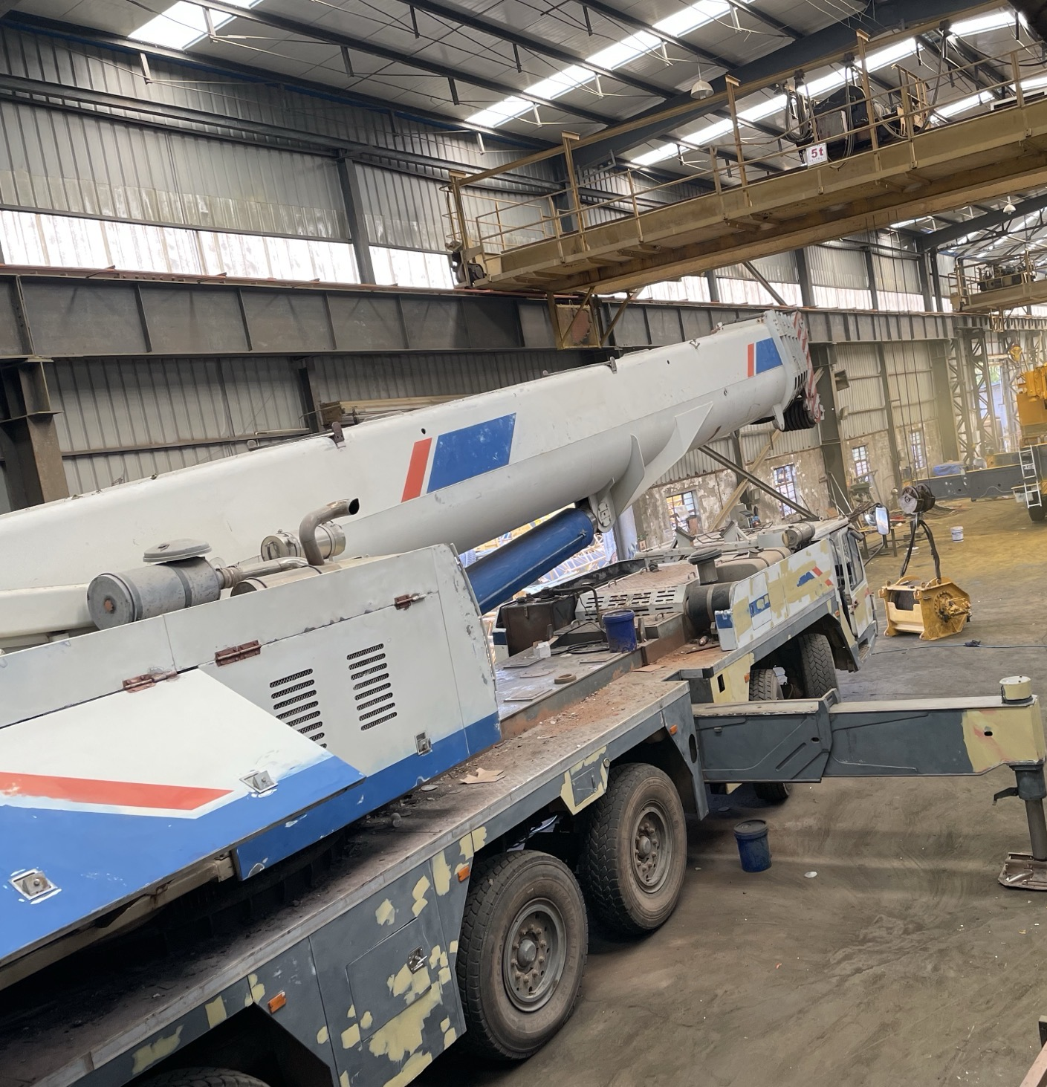
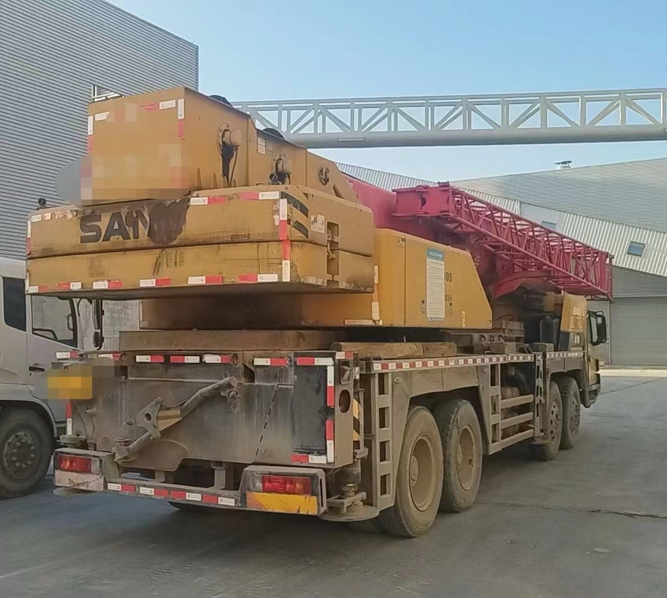
• Initial Assessment
Conduct a thorough inspection of the machine's condition, including mechanical, hydraulic, and structural components.
• Disassembly
Dismantle key parts for deep cleaning, maintenance, and replacement if necessary.
• Cleaning & Sandblasting
Remove dirt, rust, and old paint from the machine using industrial cleaning methods and sandblasting.
• Repair & Replacement
Repair worn-out components and replace damaged or non-functional parts with genuine or high-quality alternatives.
• Painting & Surface Treatment
Repaint the machinery with industrial-grade coatings for improved appearance and durability.
• Reassembly
Carefully reassemble all components and perform system checks.
• Functional Testing
Conduct full-scale performance tests to ensure the machine operates reliably and meets safety standards.
• Final Inspection & Quality Control
Perform a final inspection to verify that the machine is refurbished to meet company and customer standards.
• Delivery Preparation
Clean, package, and prepare the machine for delivery or customer pickup.
Refurbishment Workflow
www.betalifting.com

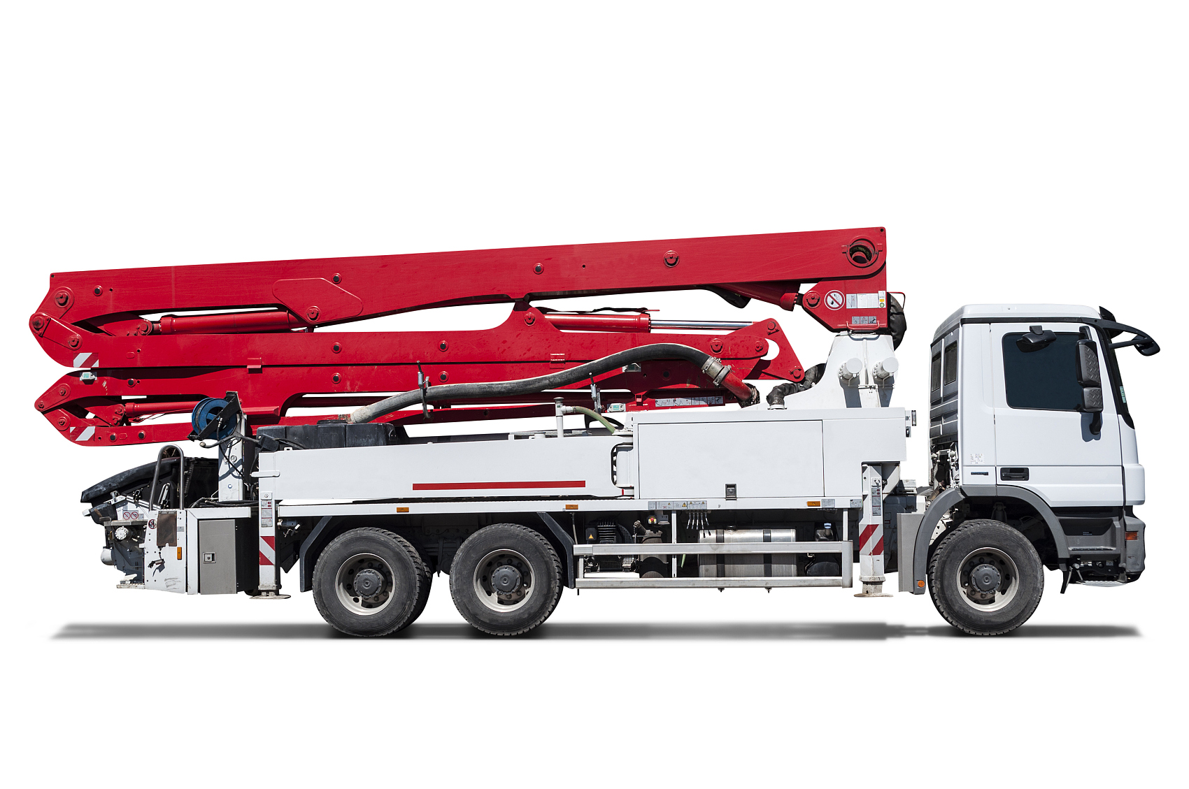
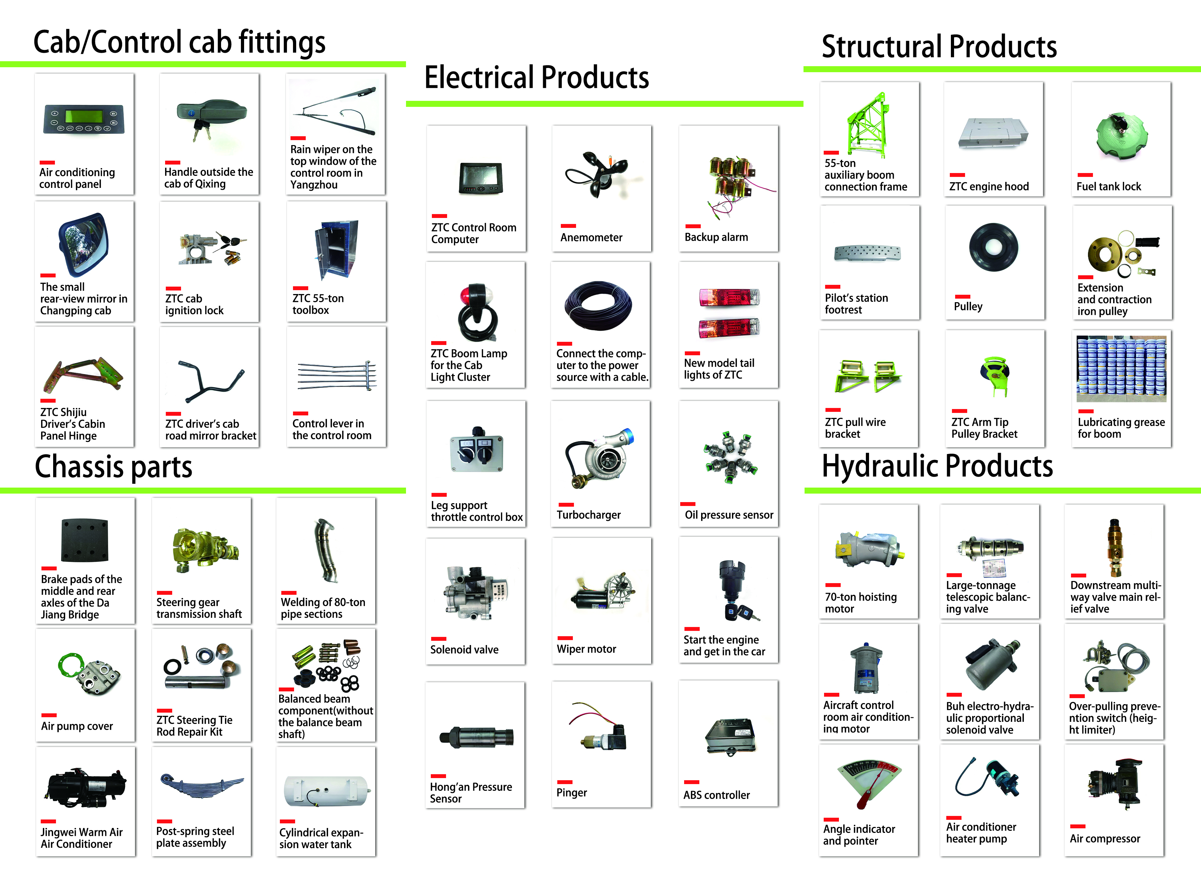
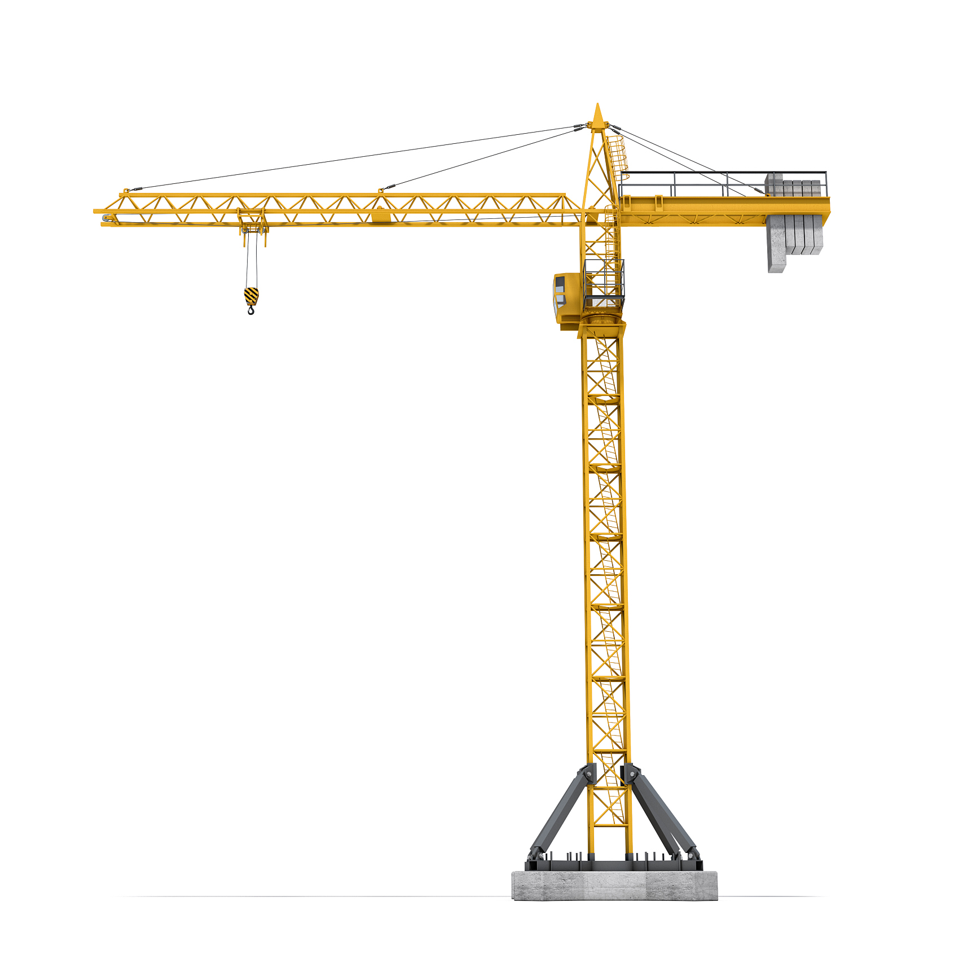
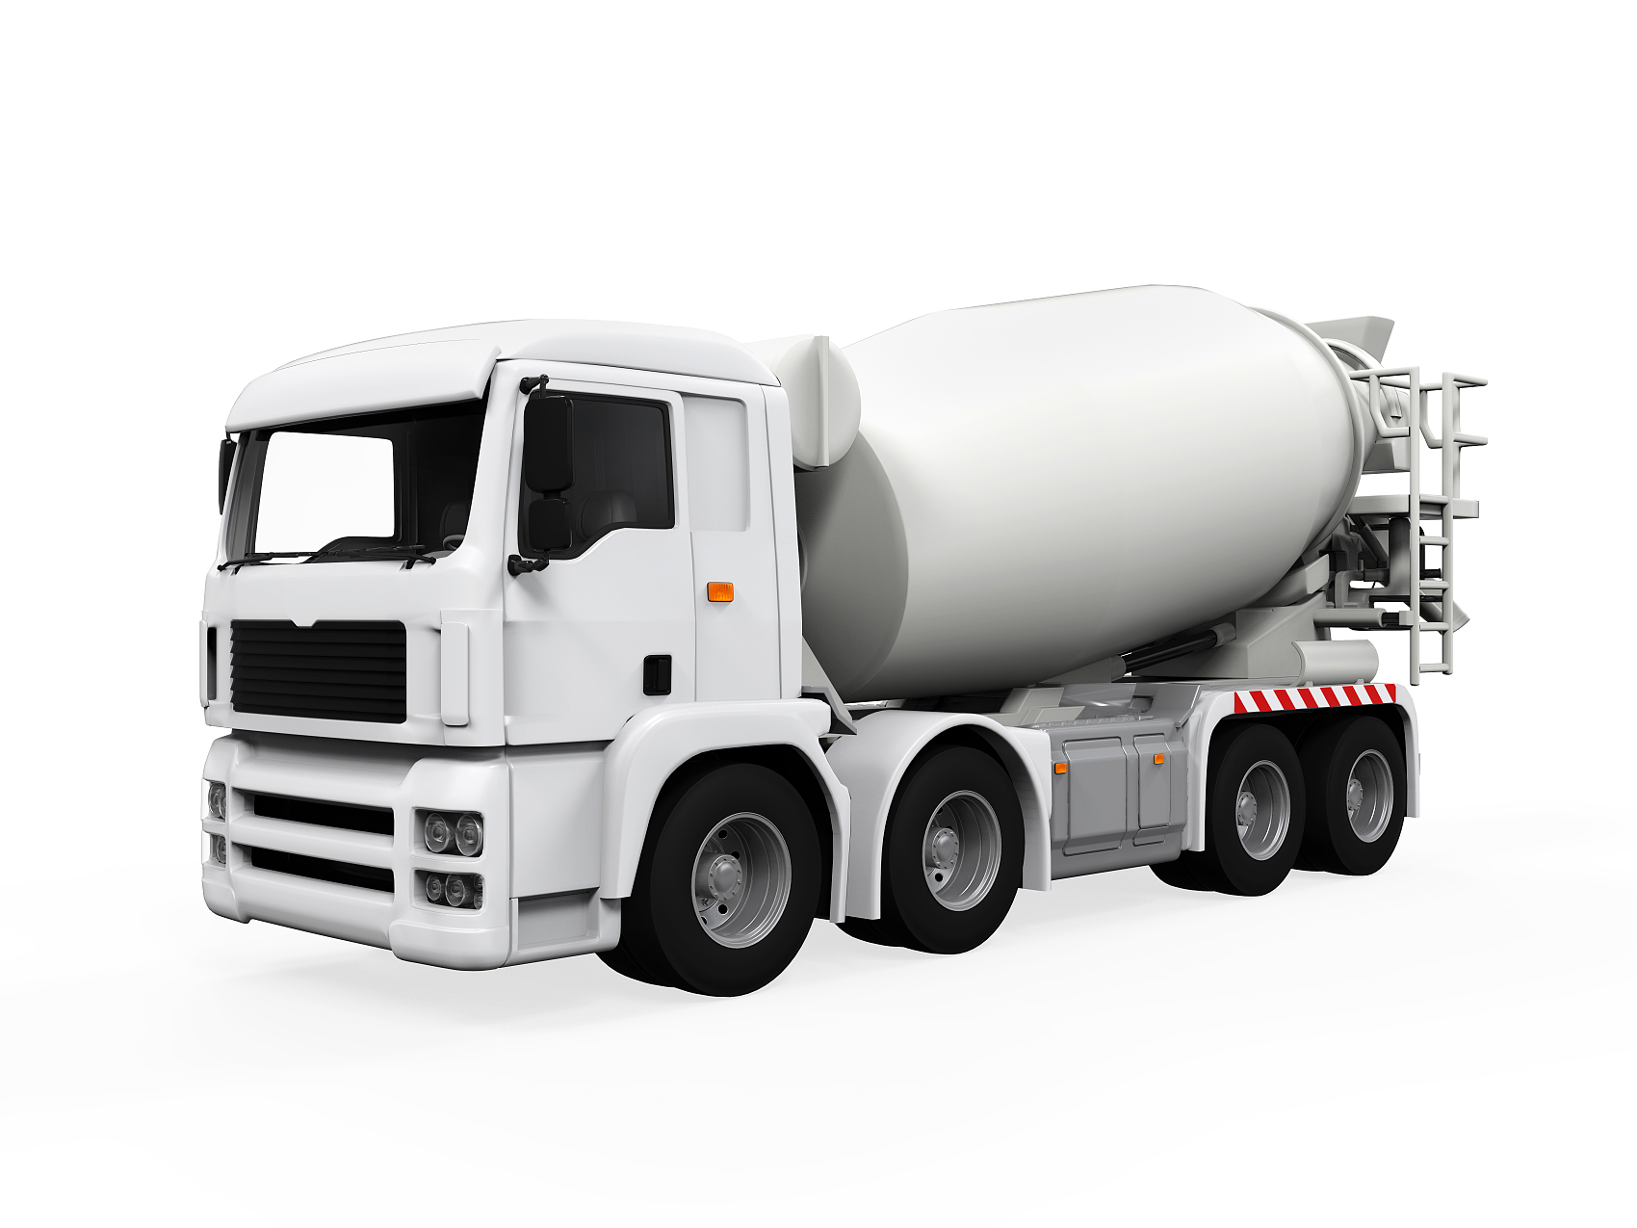
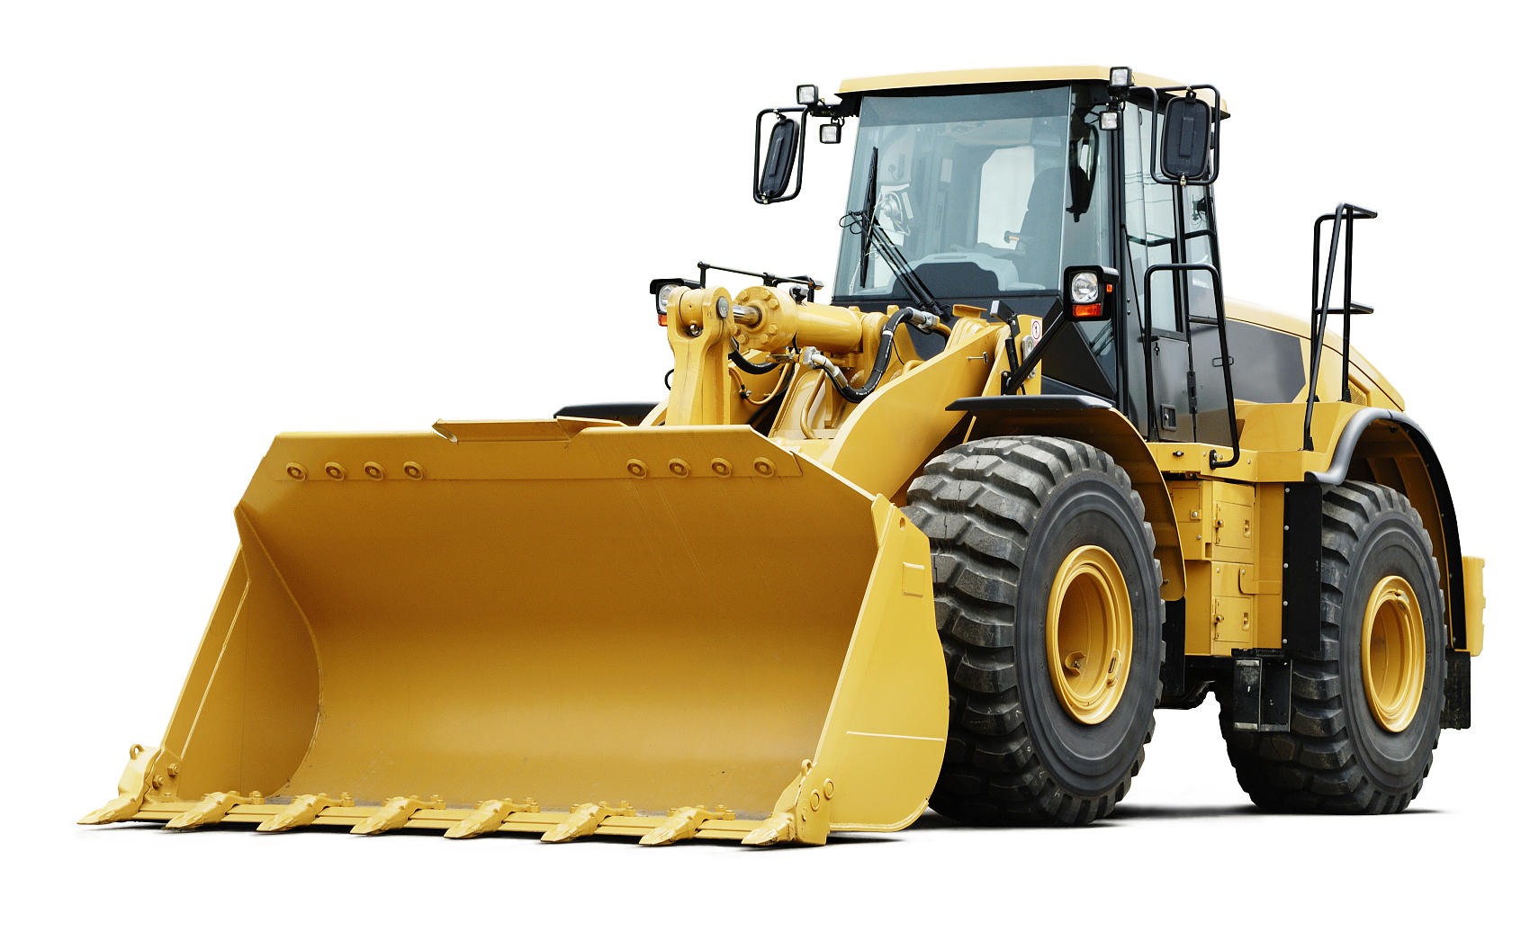
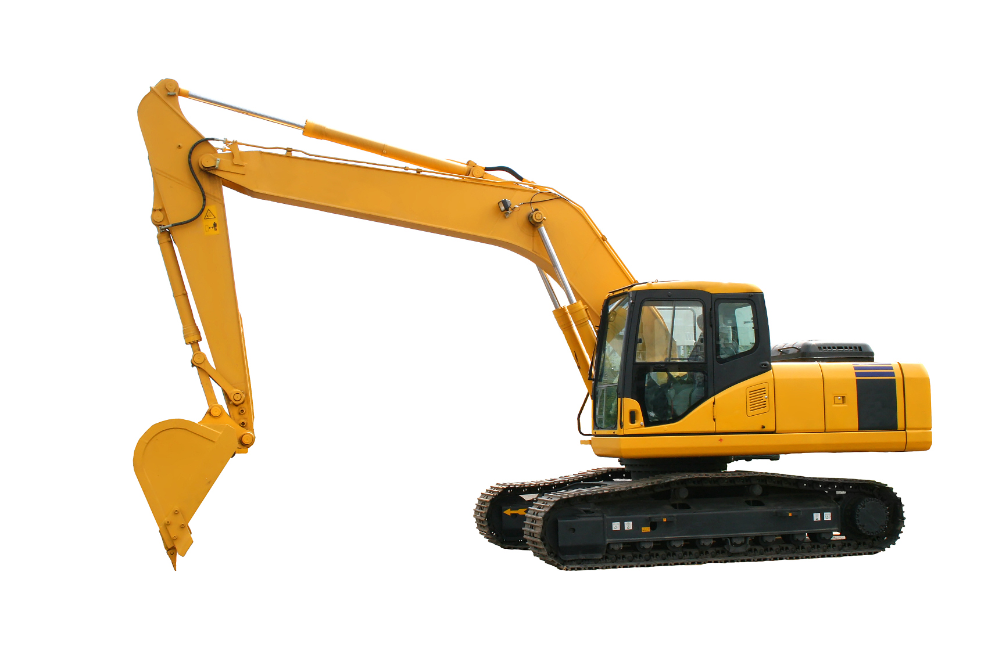
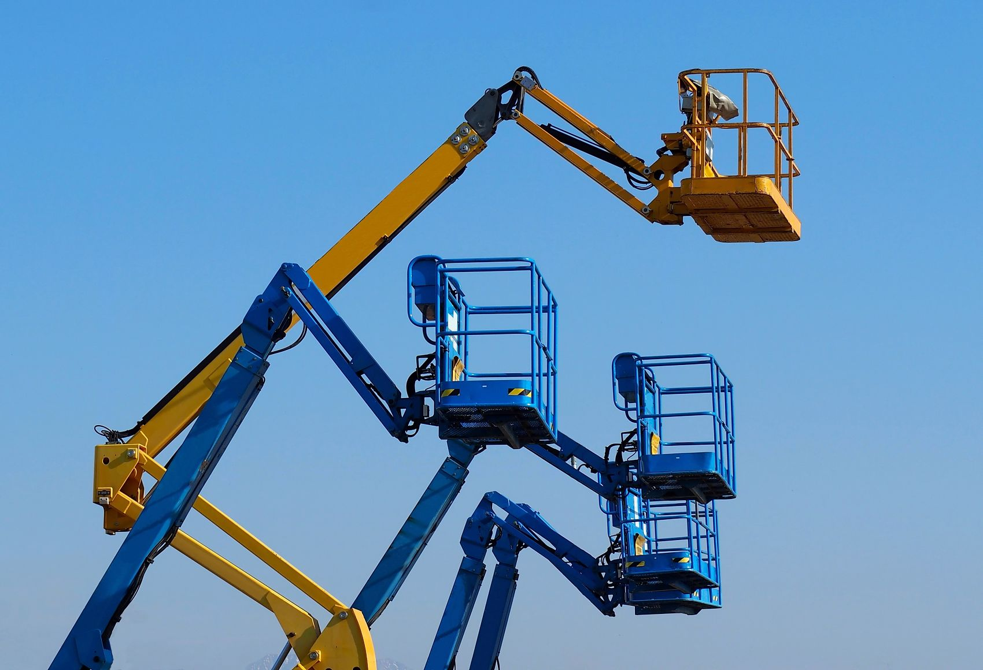
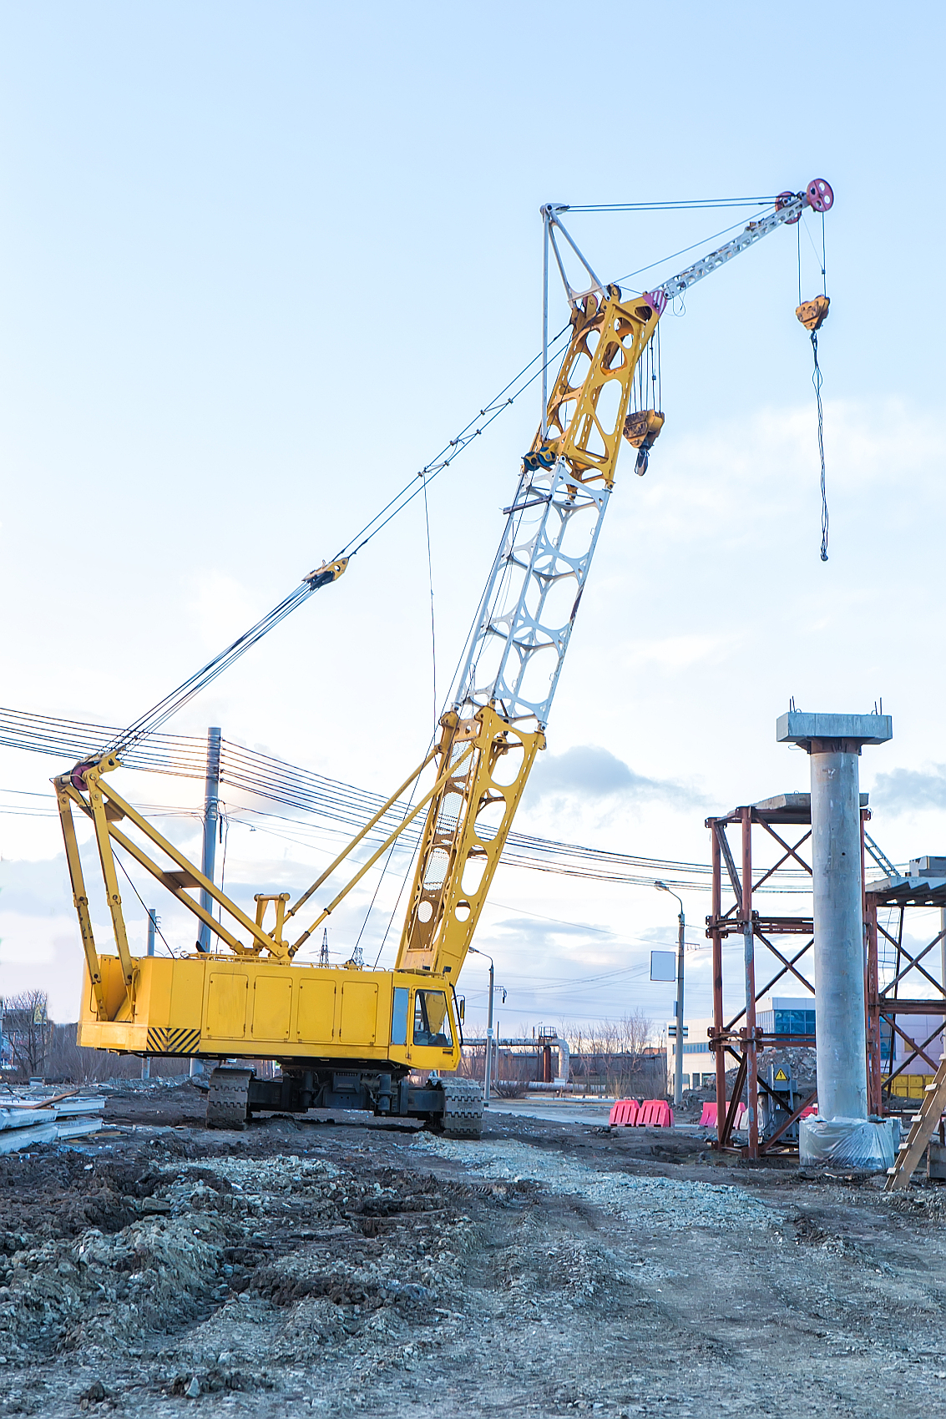
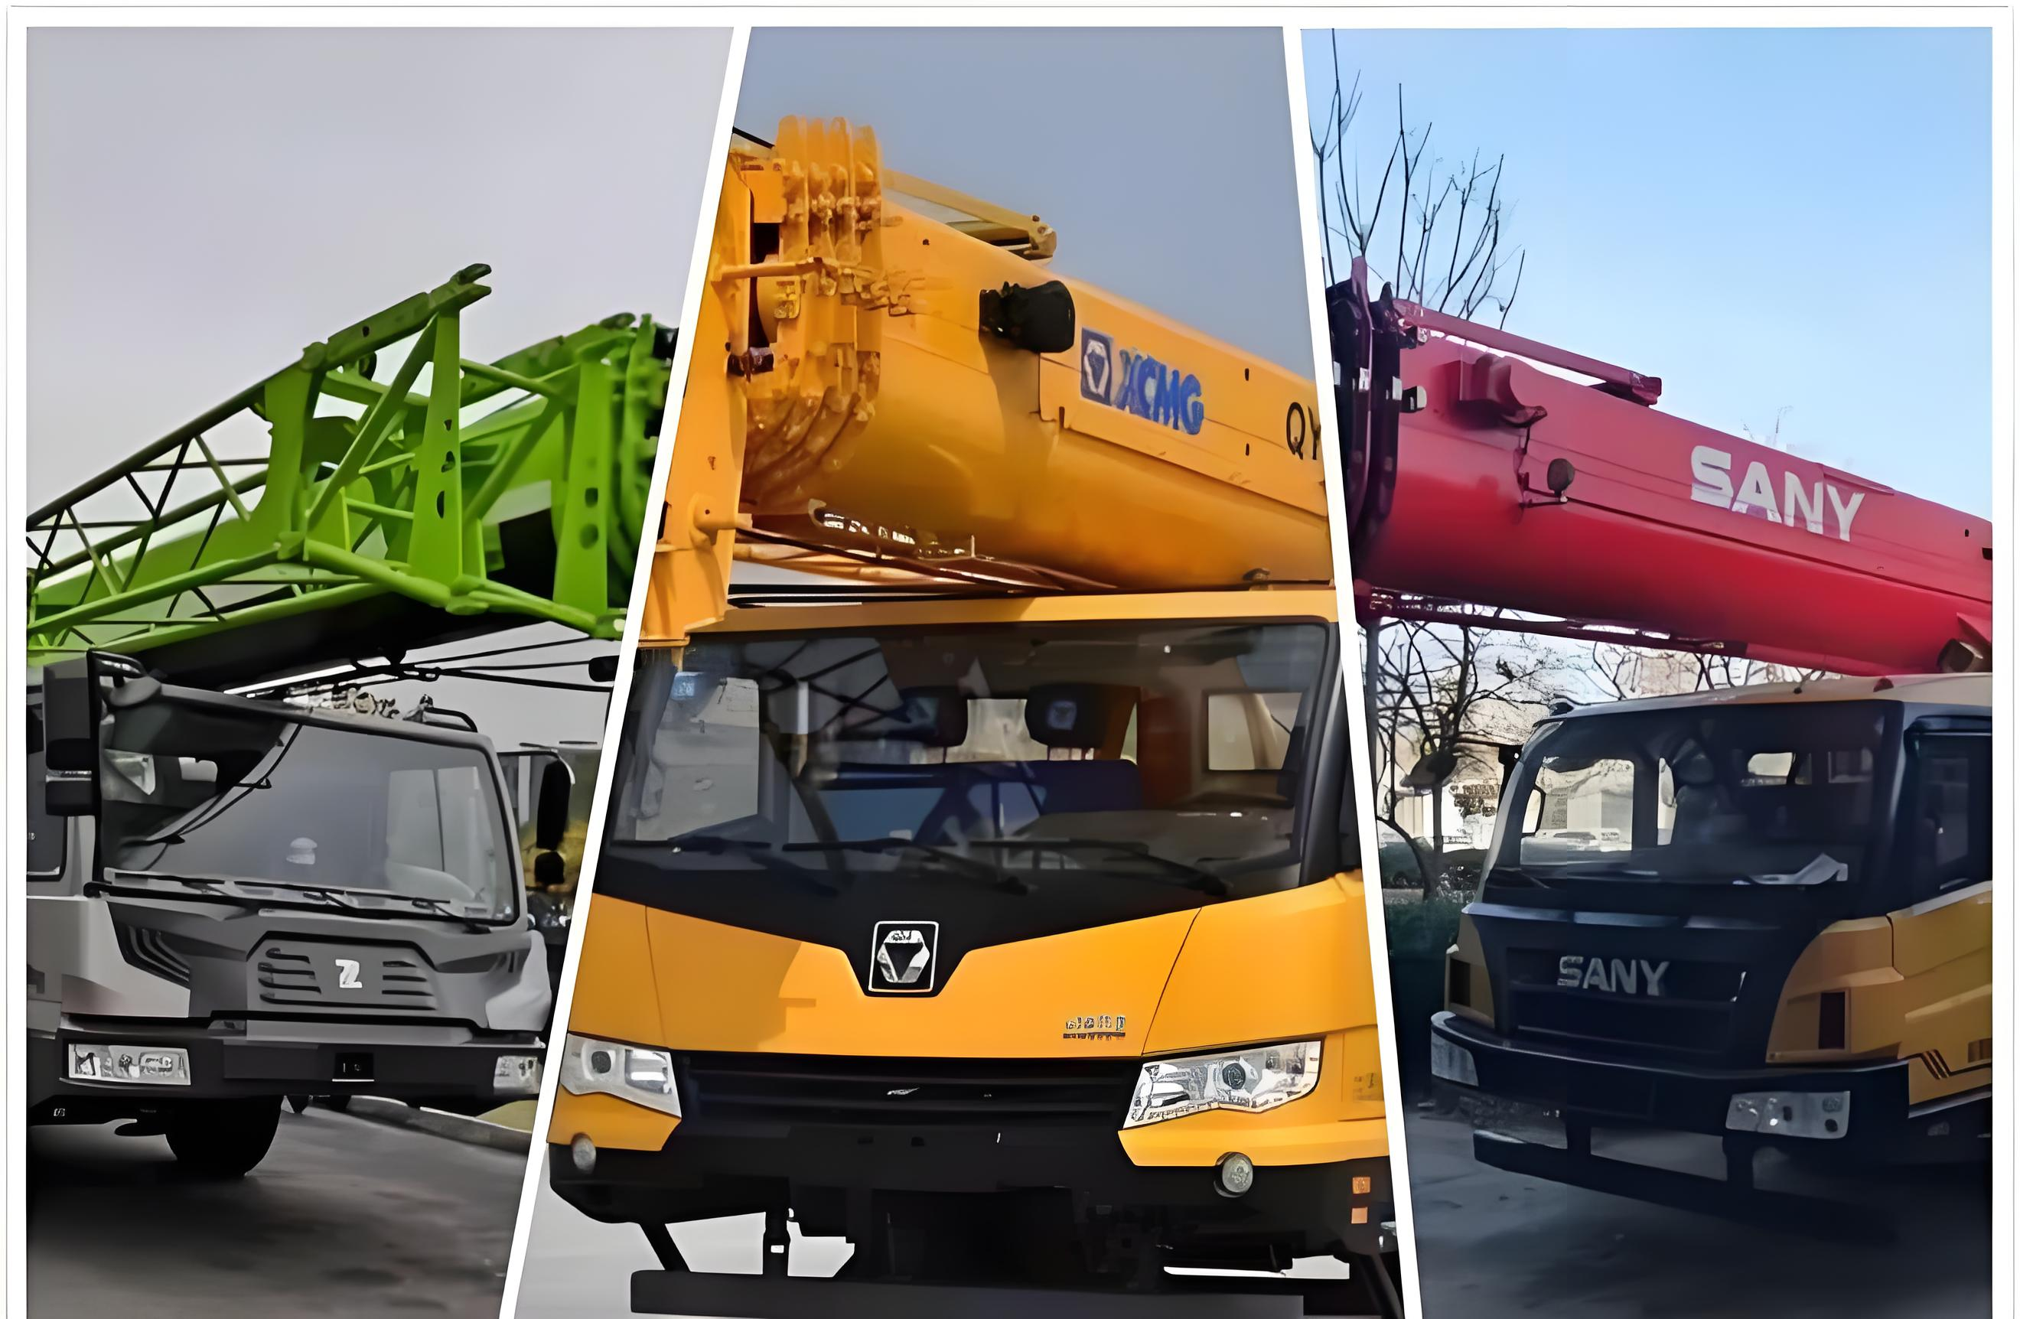
Used Truck Crane/All-Terrain Crane
Used Concrete Pump Truck

Spare Parts
Used Tower Crane

Used Cement MixerTruck

Used Bulldozer
Used Excavator
Used Rotary Drilling Rig
Used Areal Work Platform/Manlift
Used Crawler
Main Products
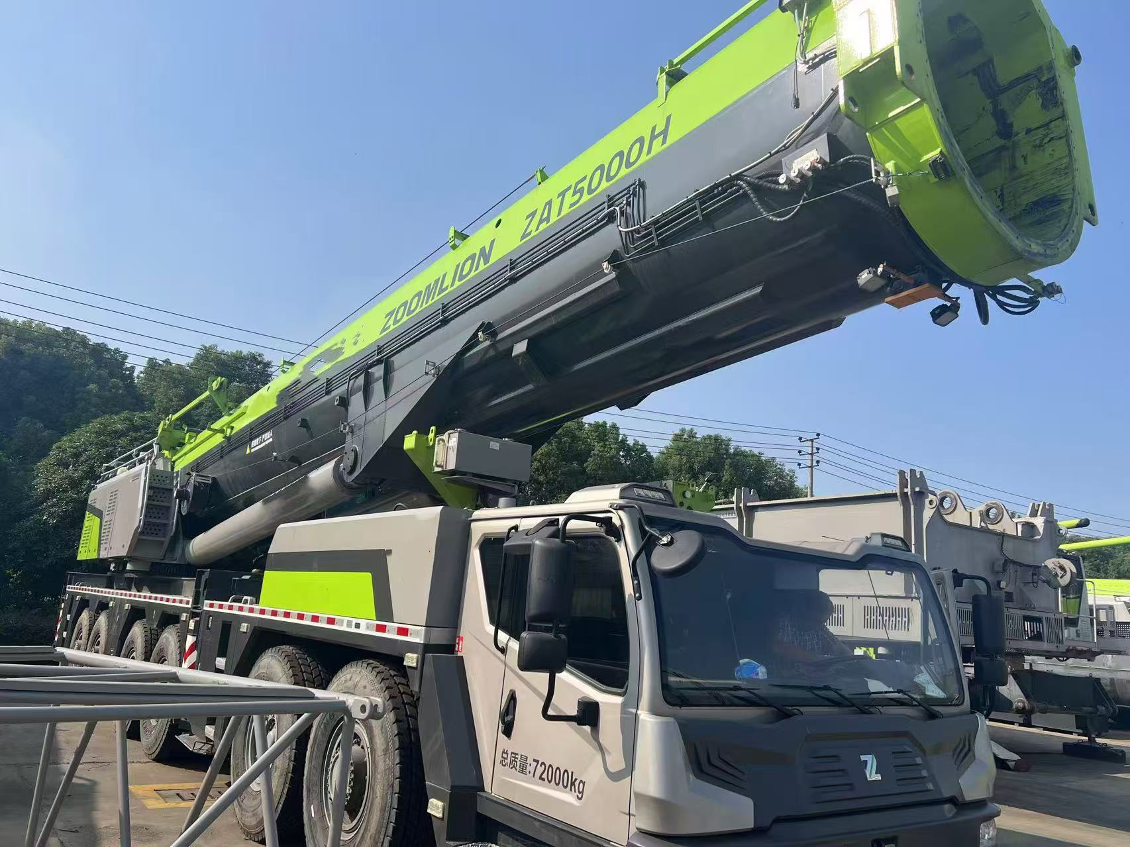
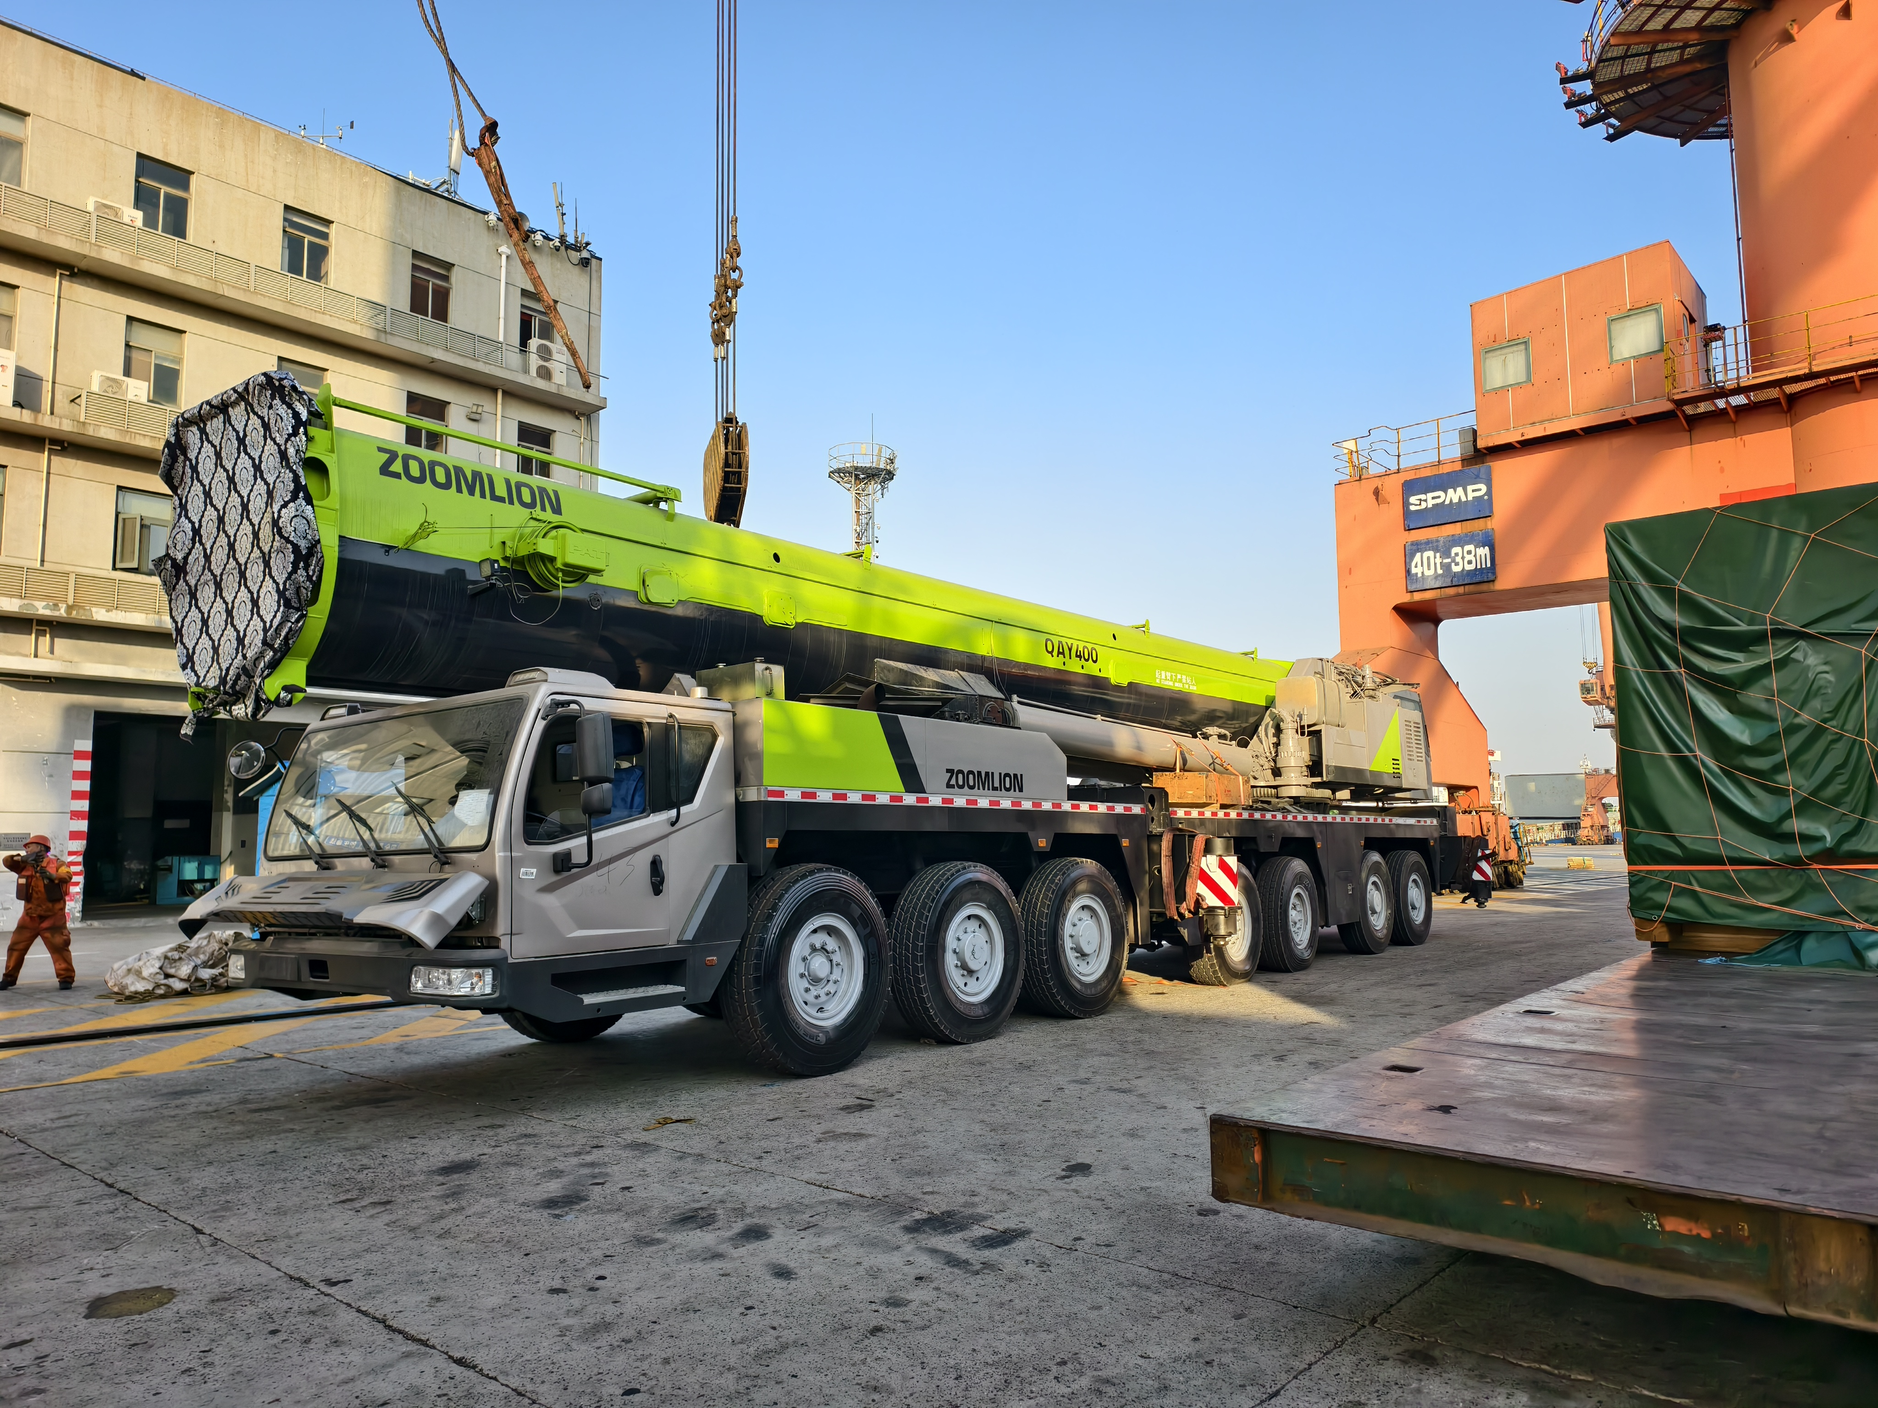
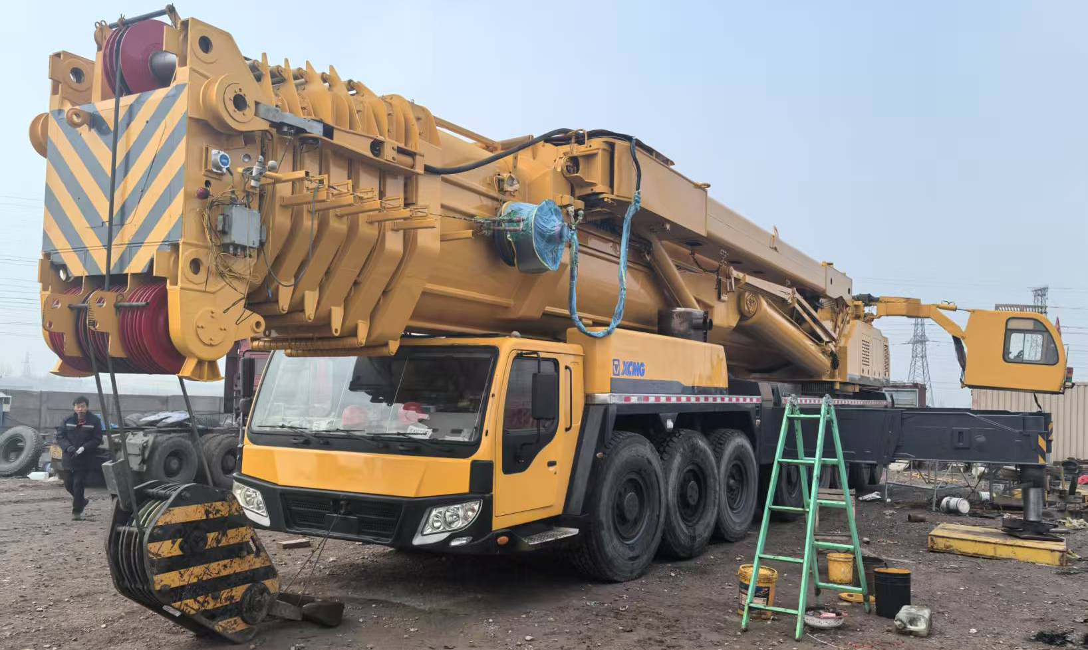
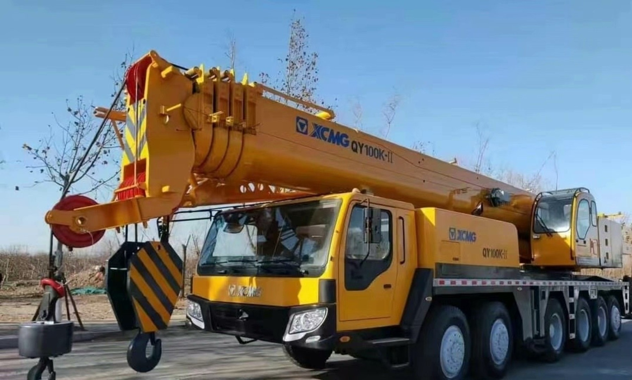
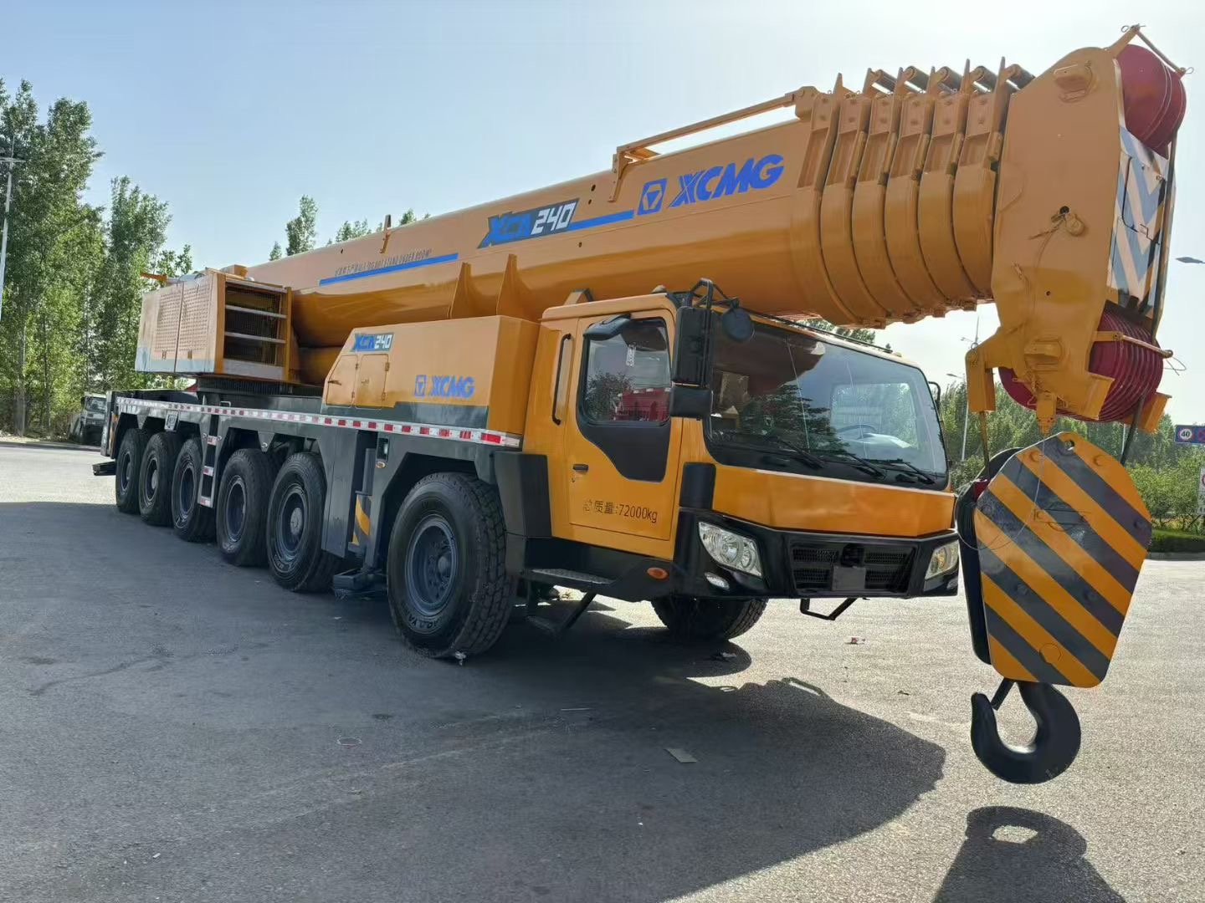
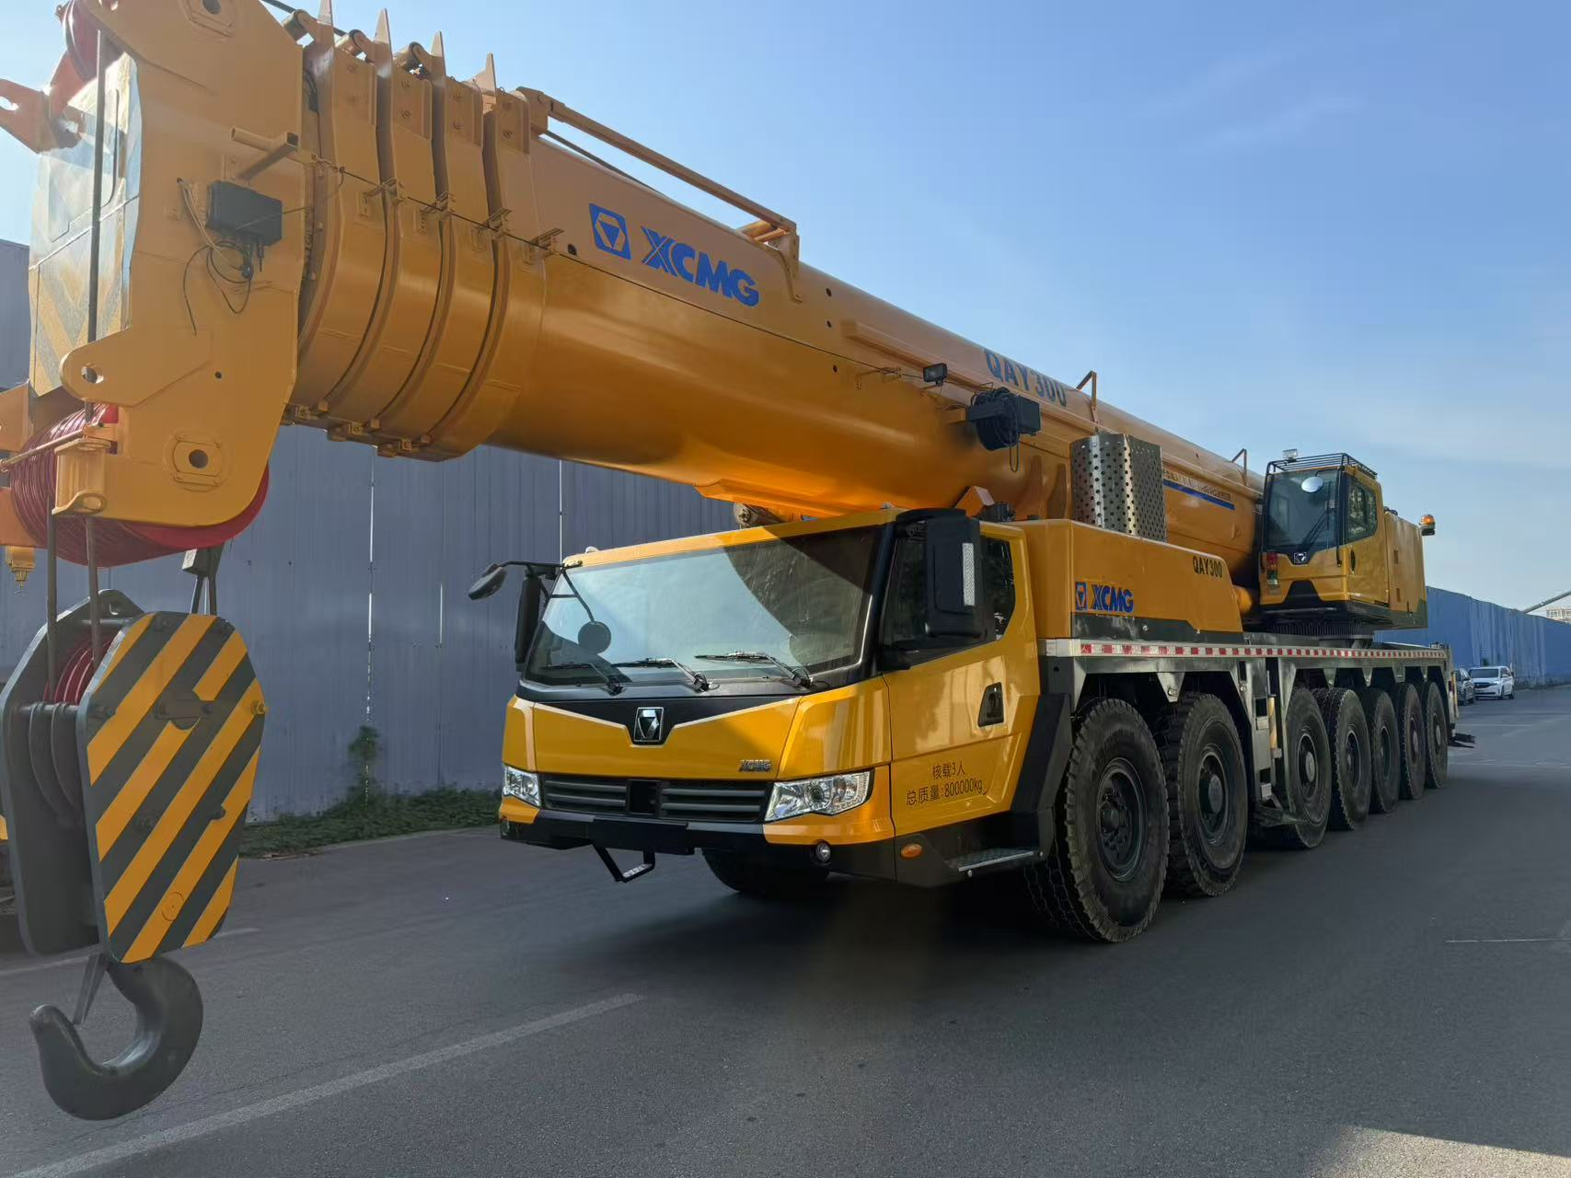
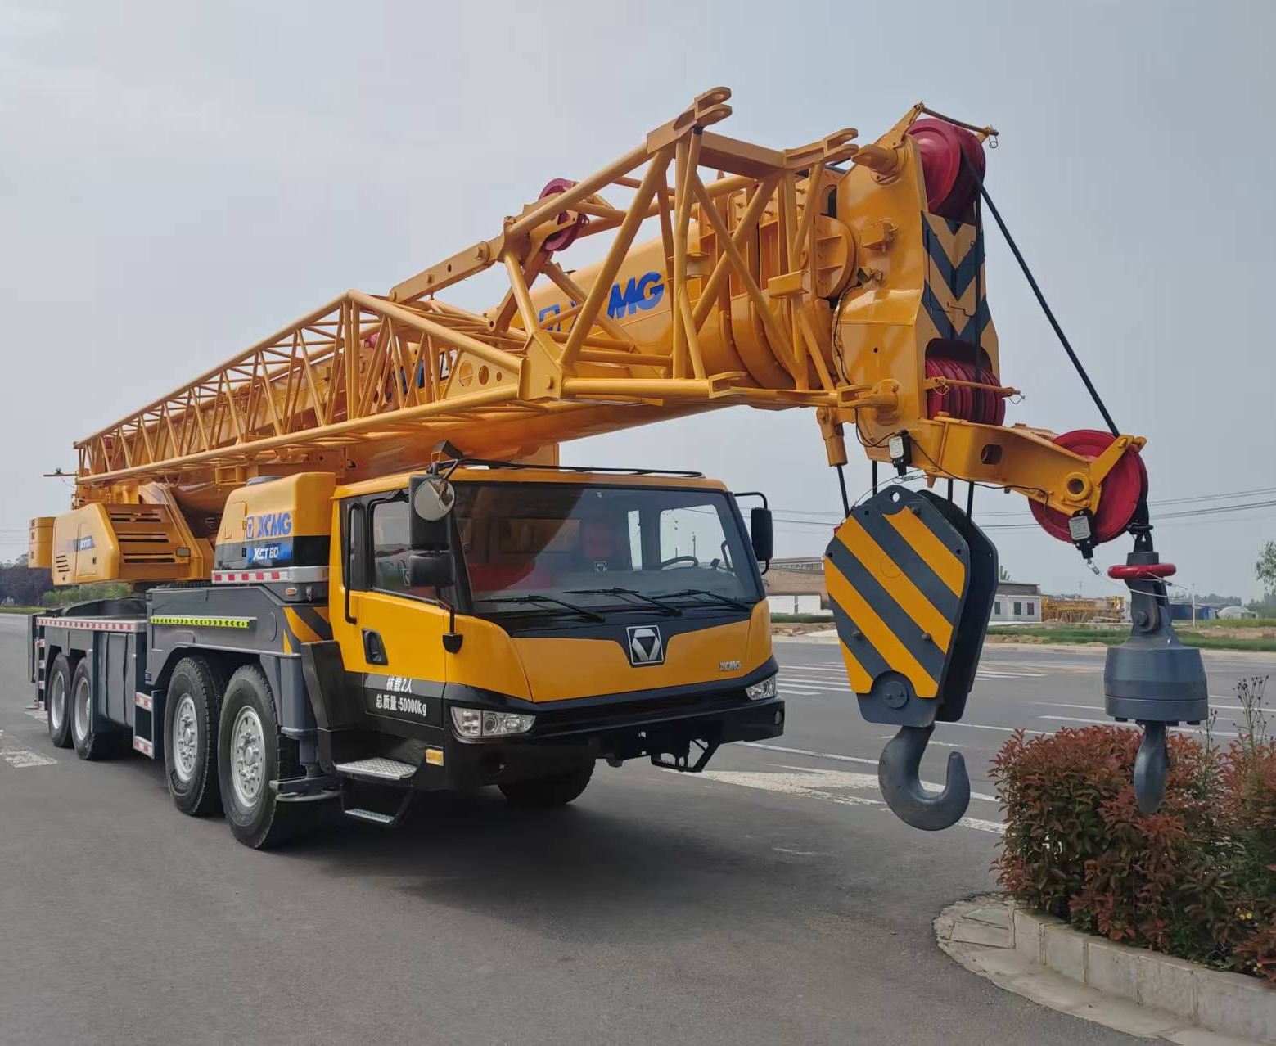
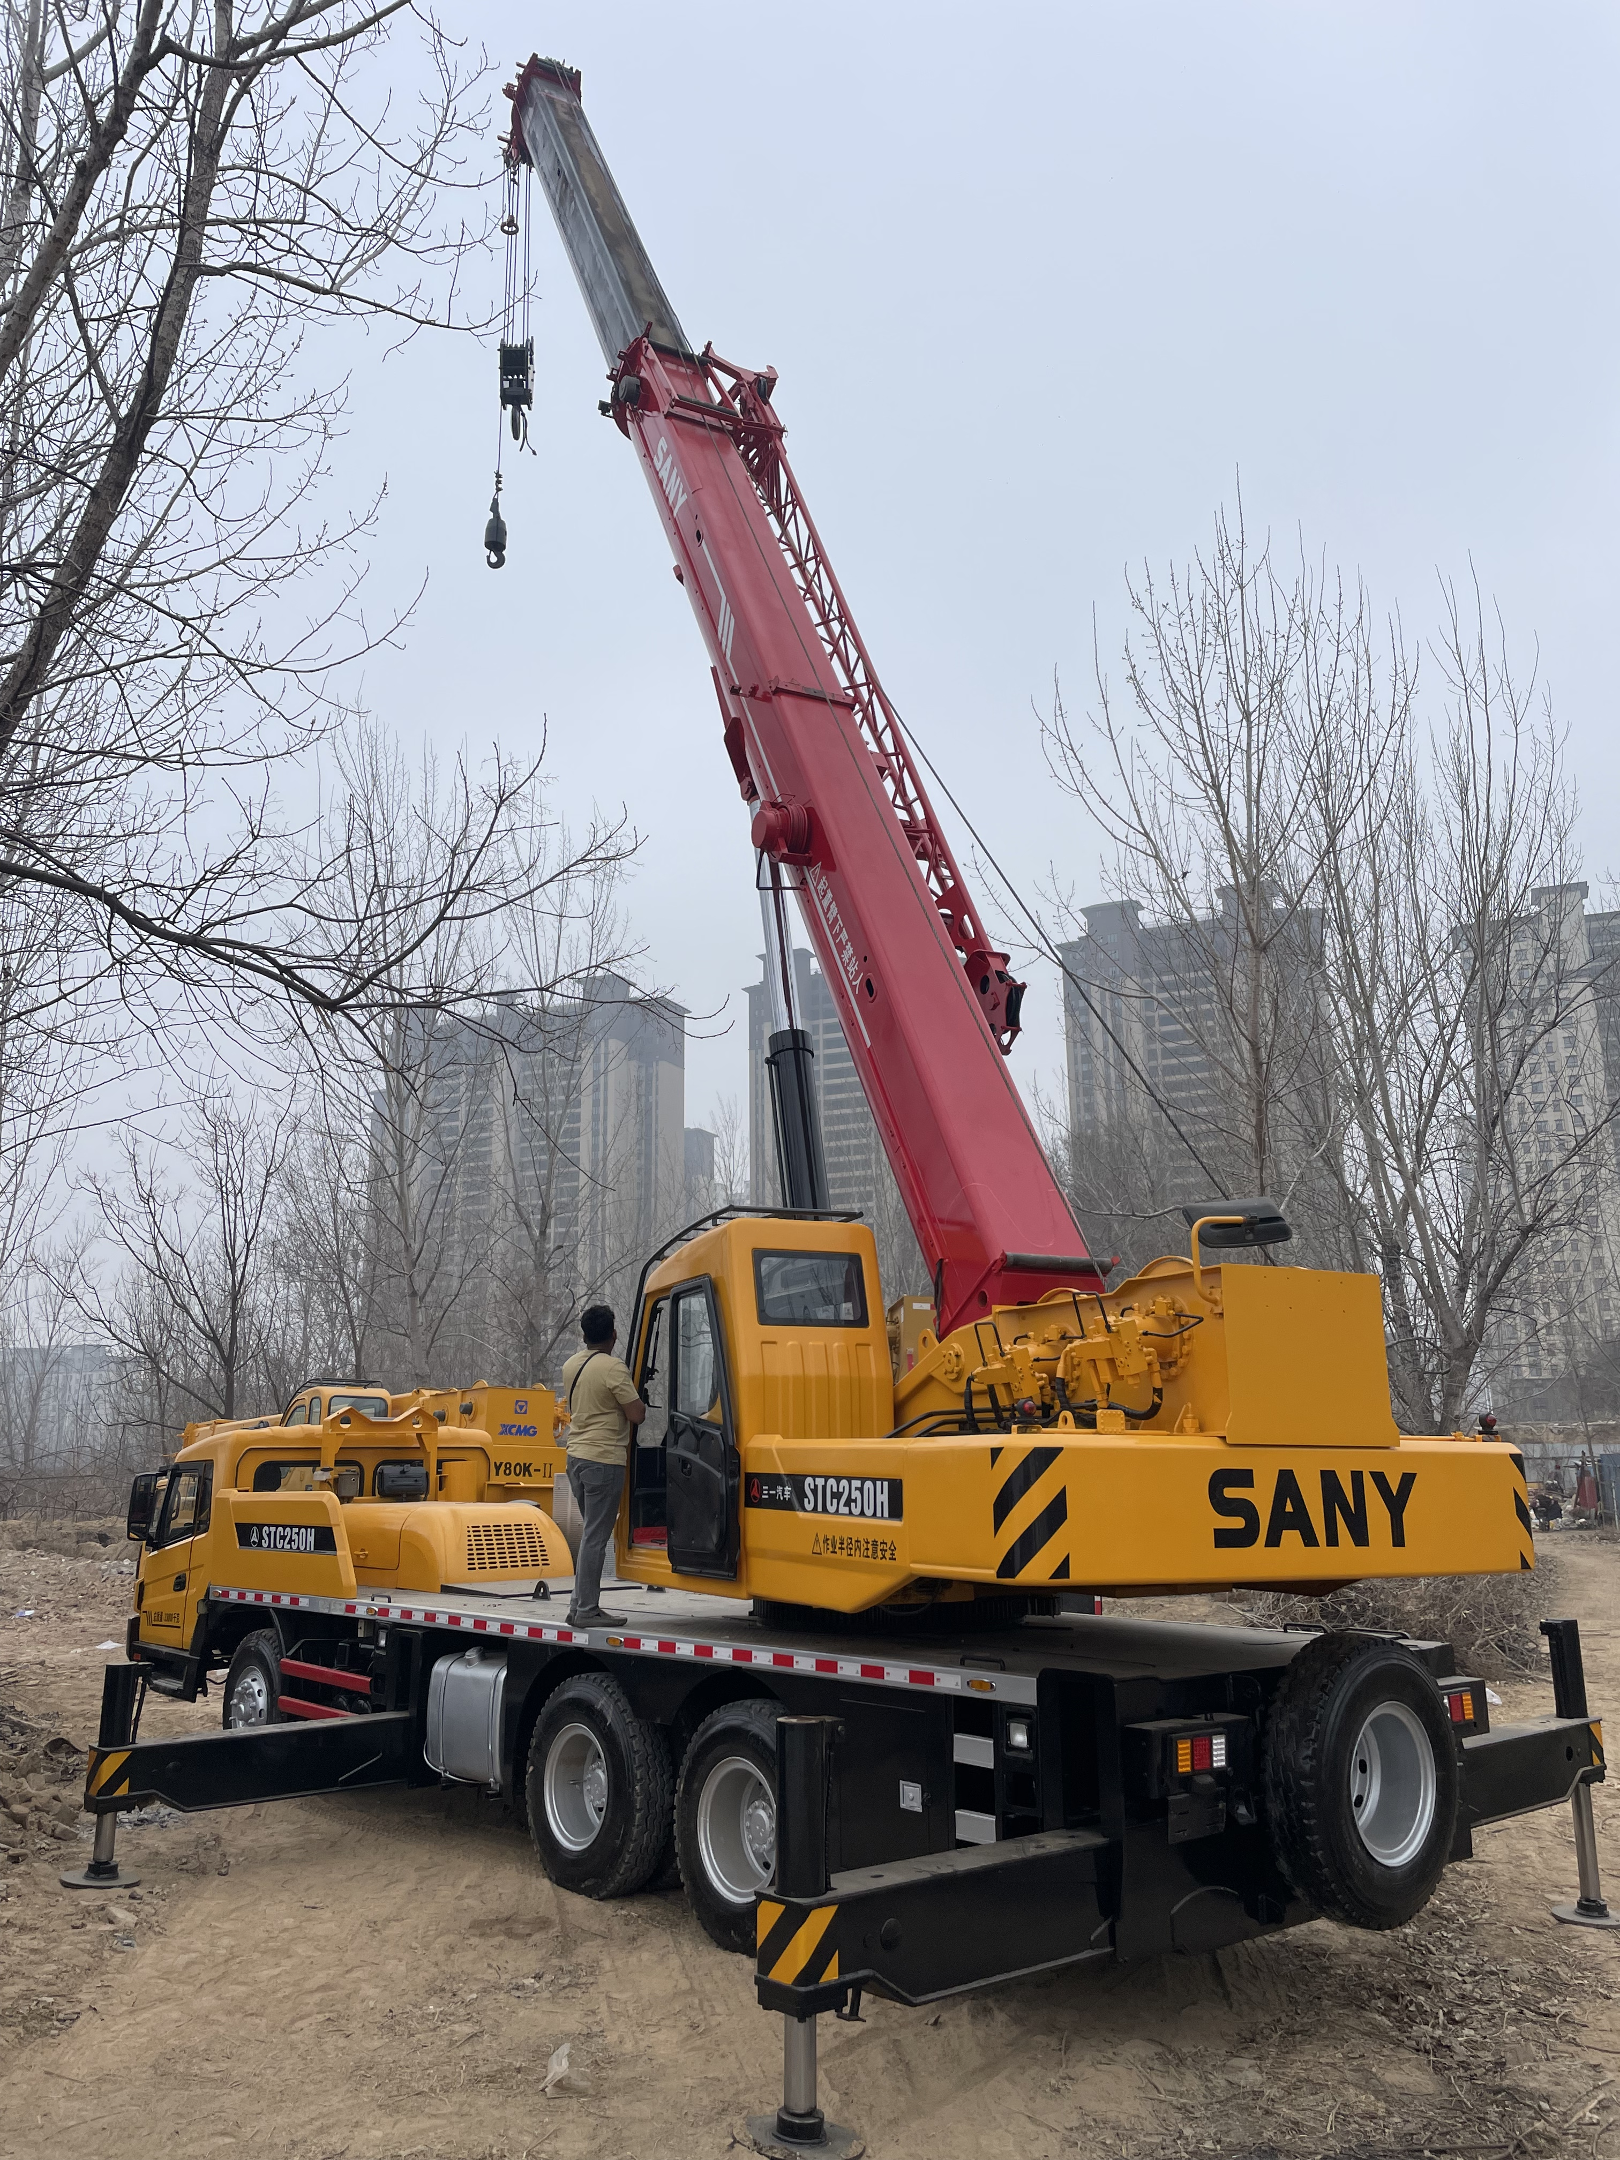
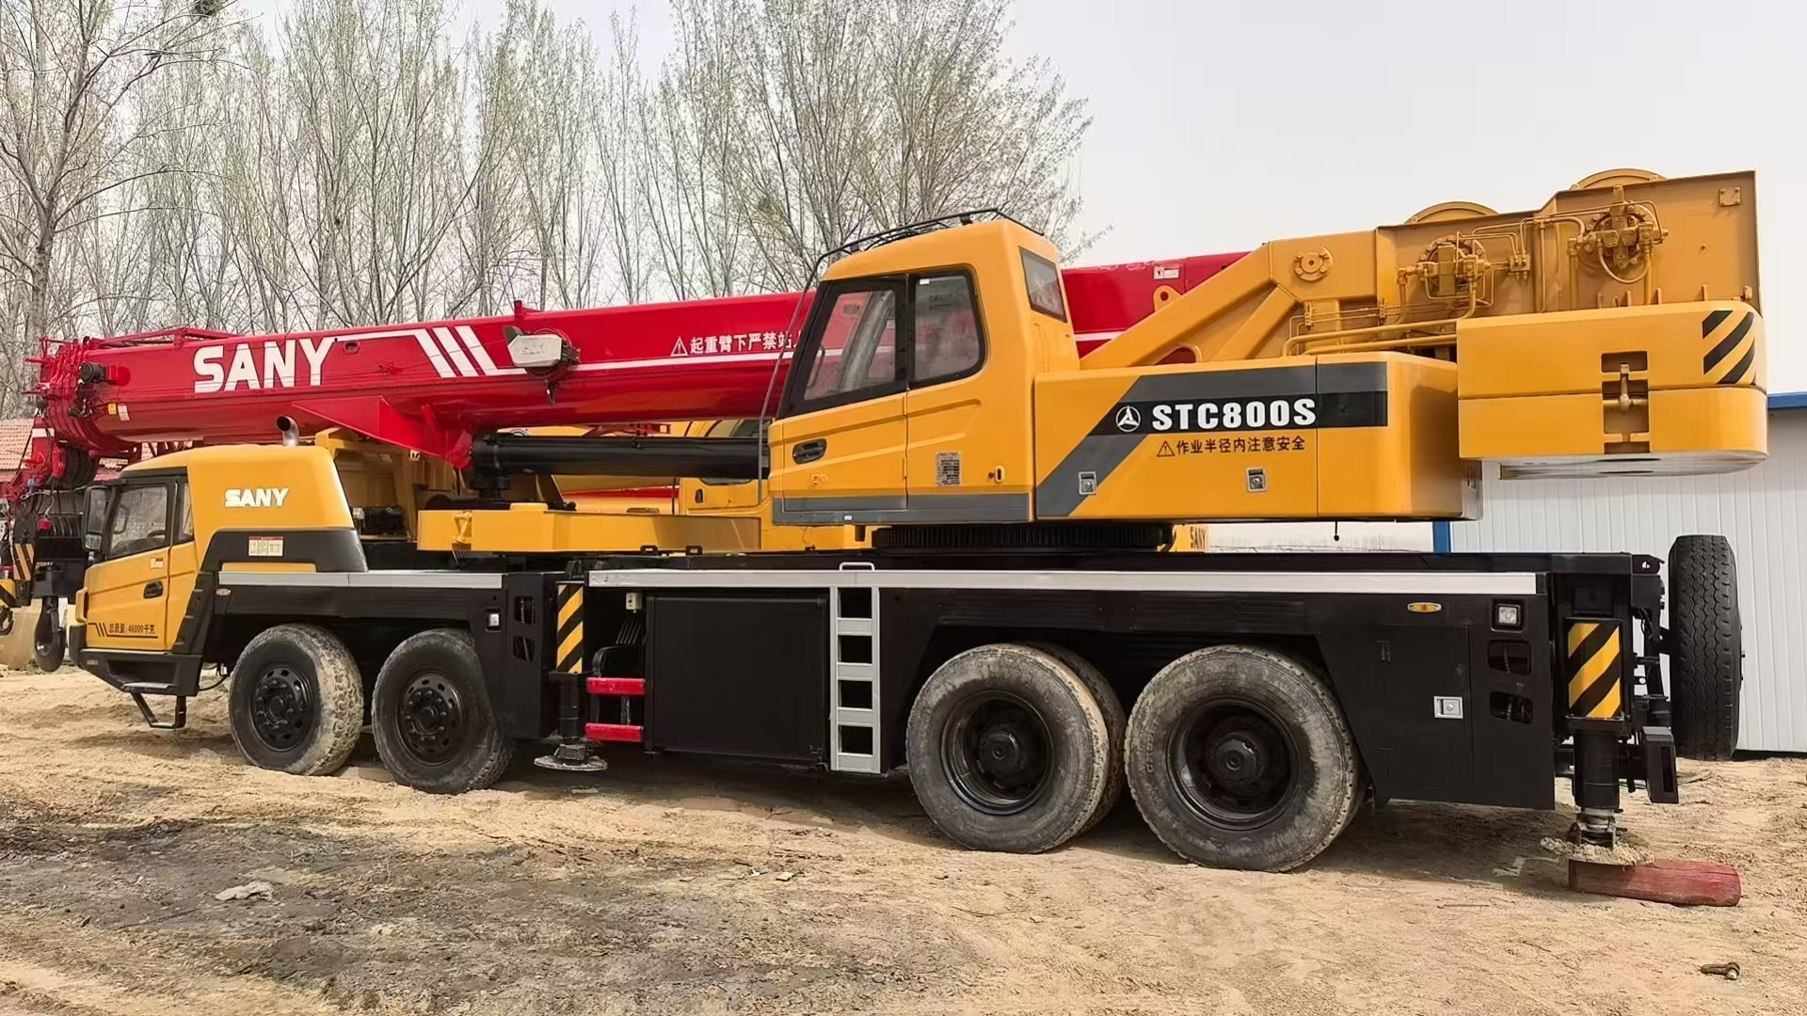
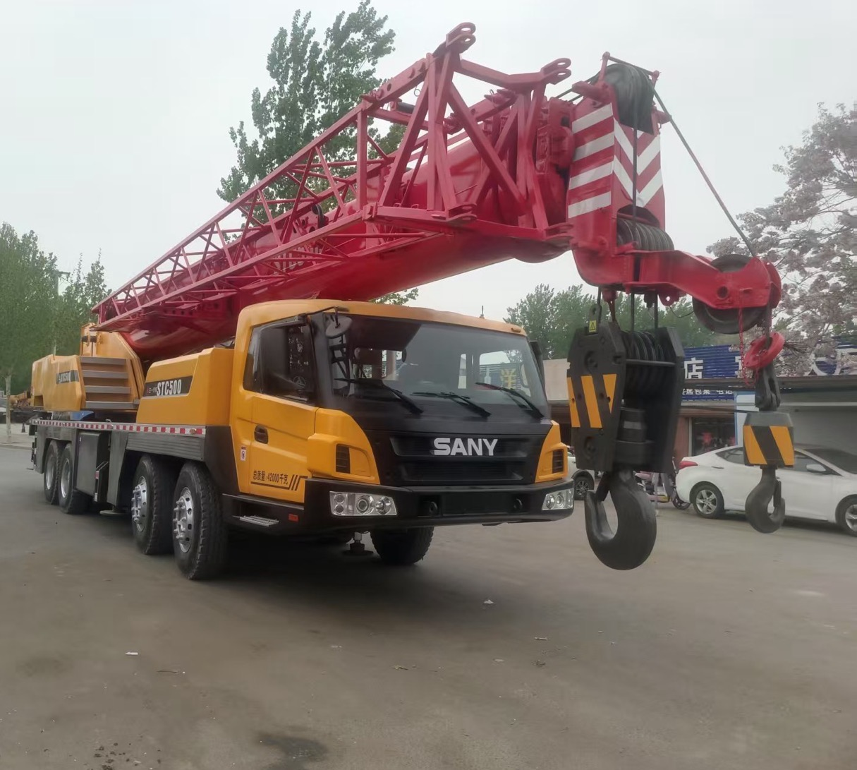
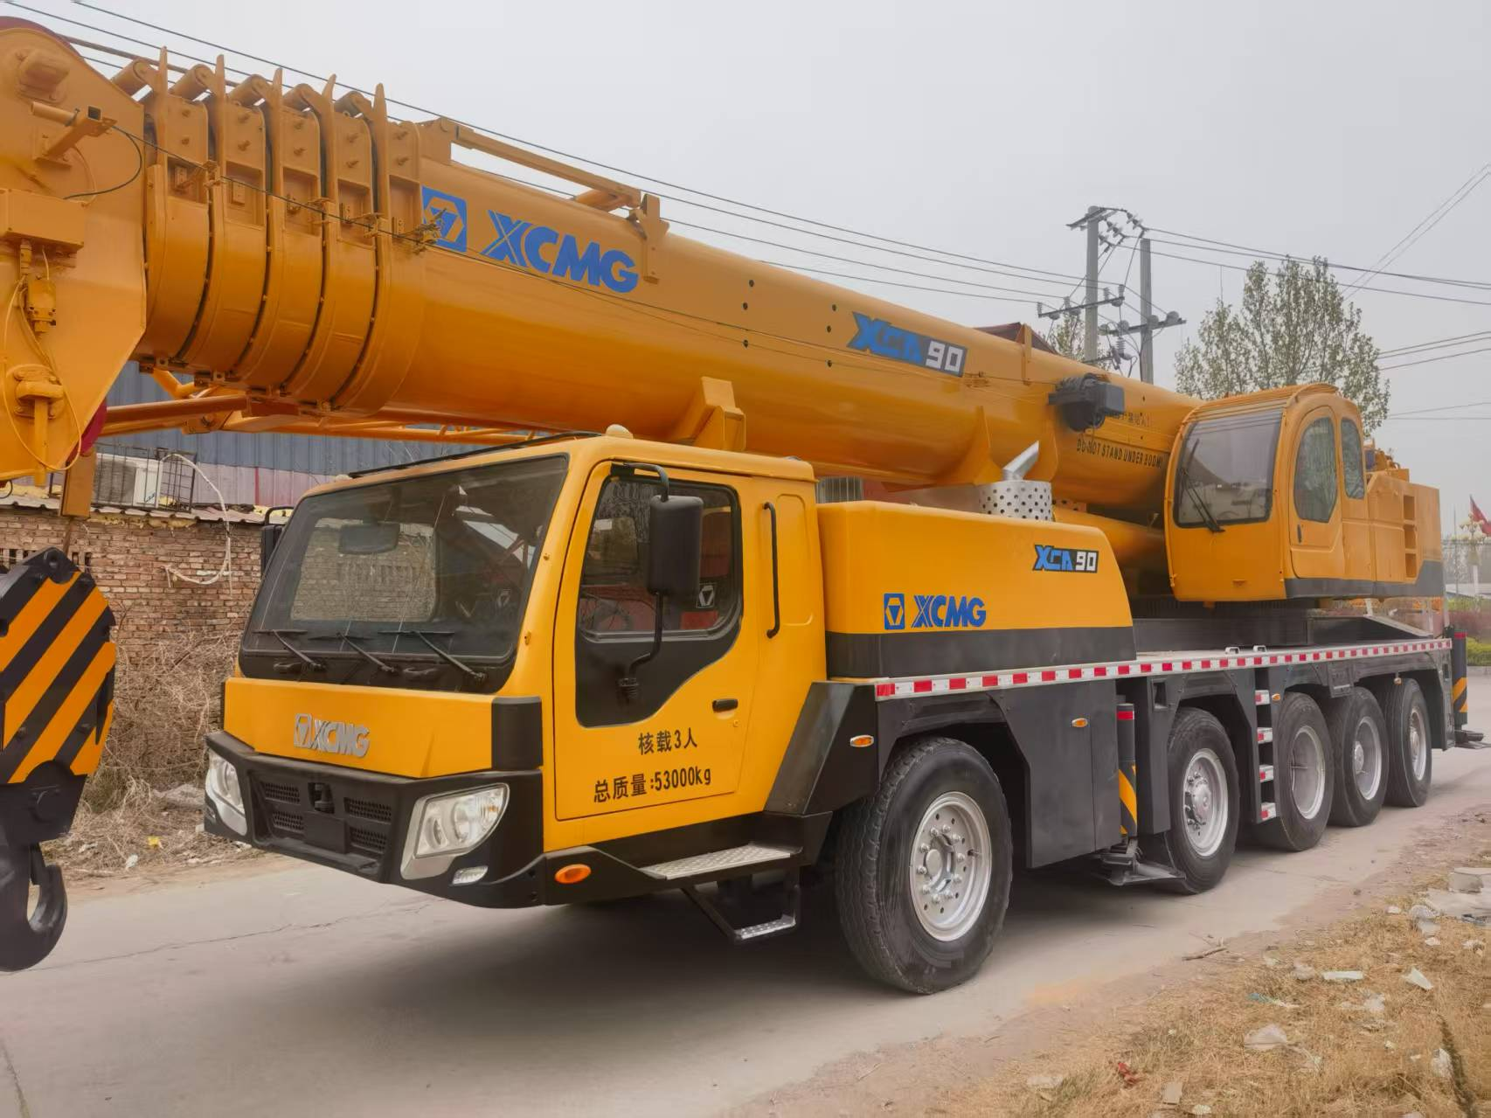
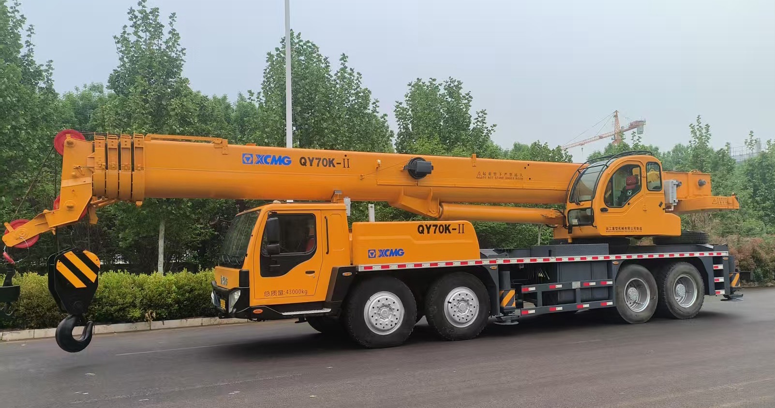
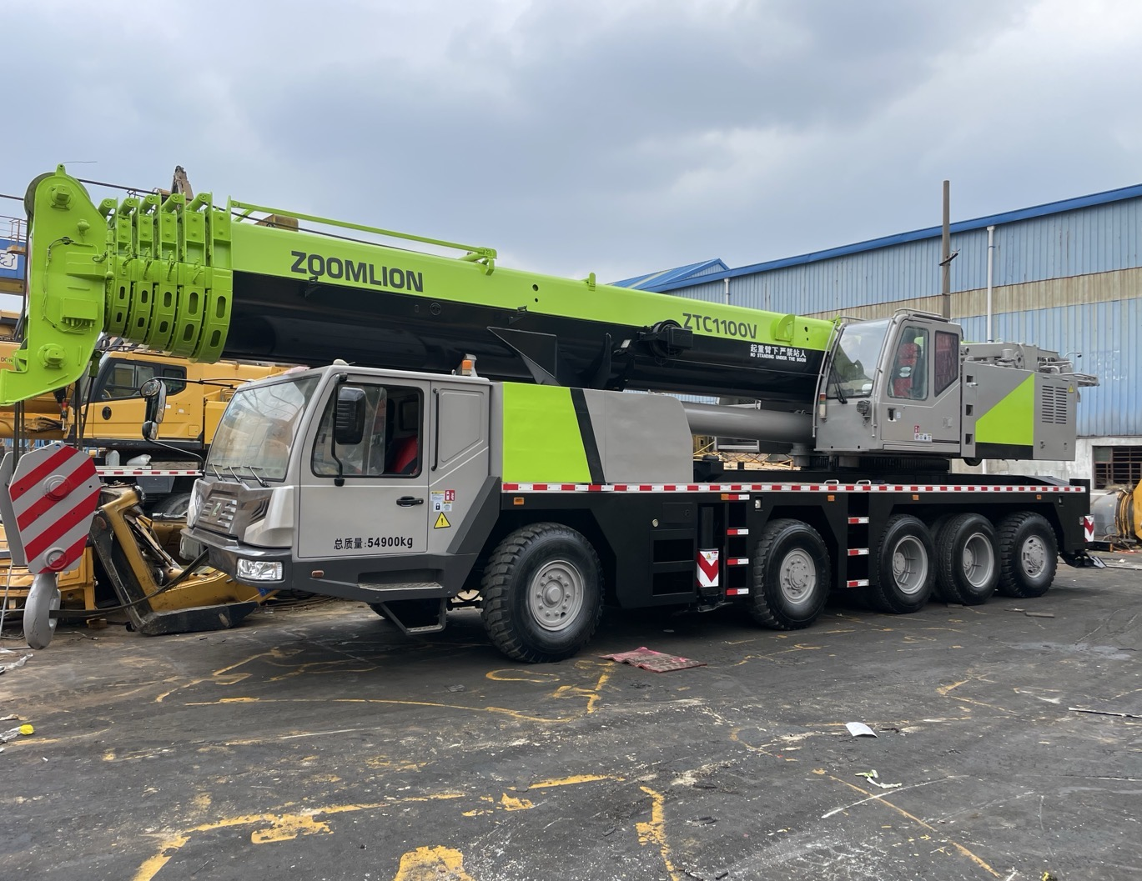
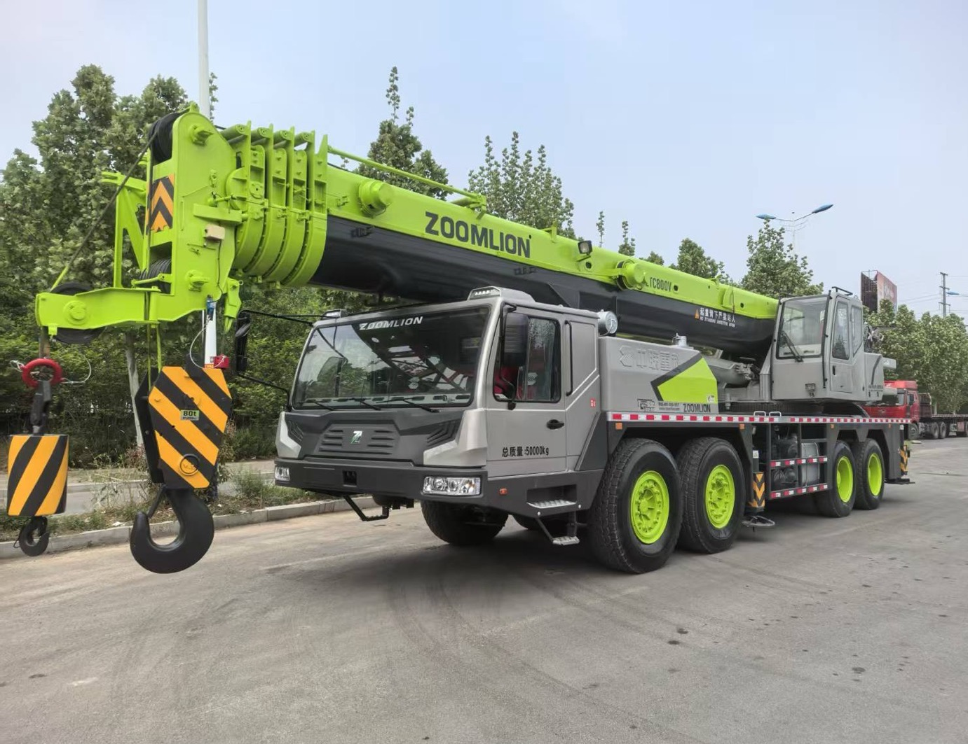
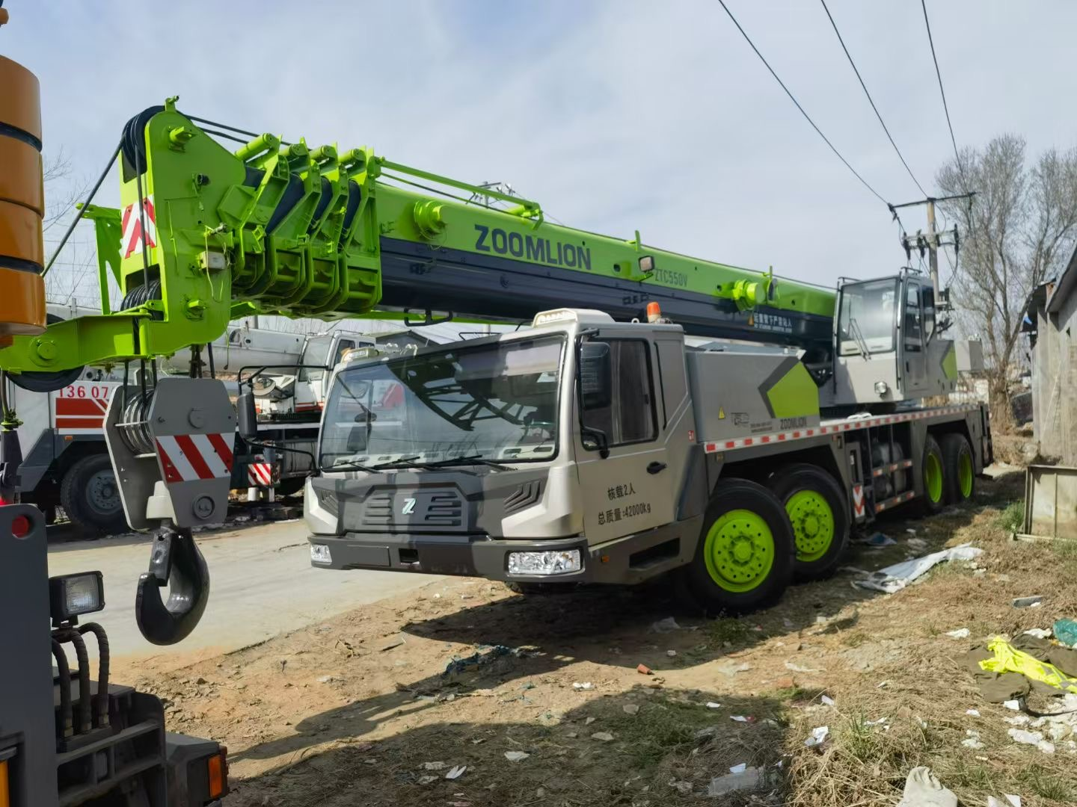
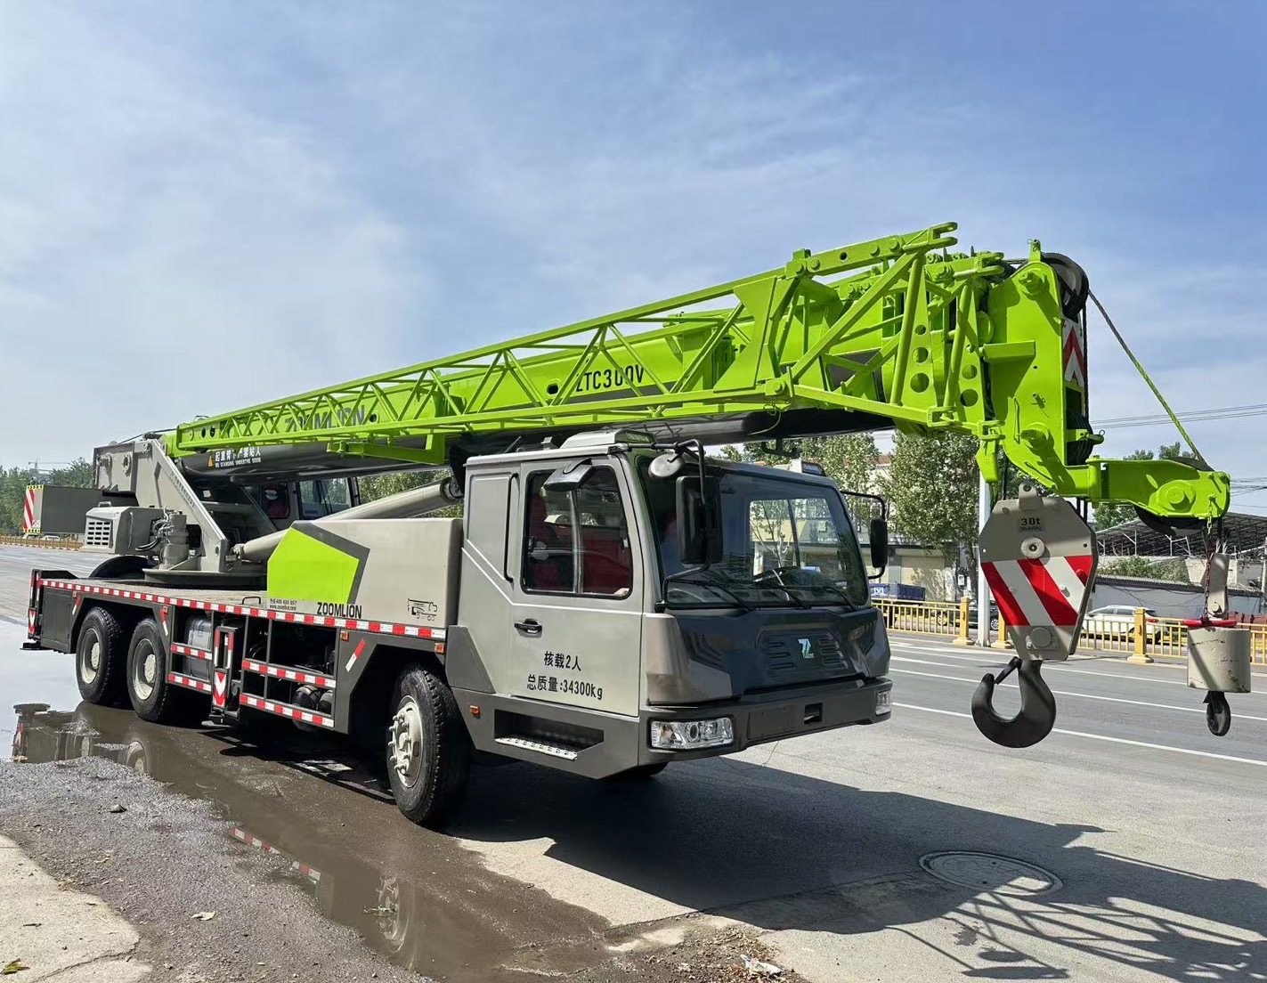
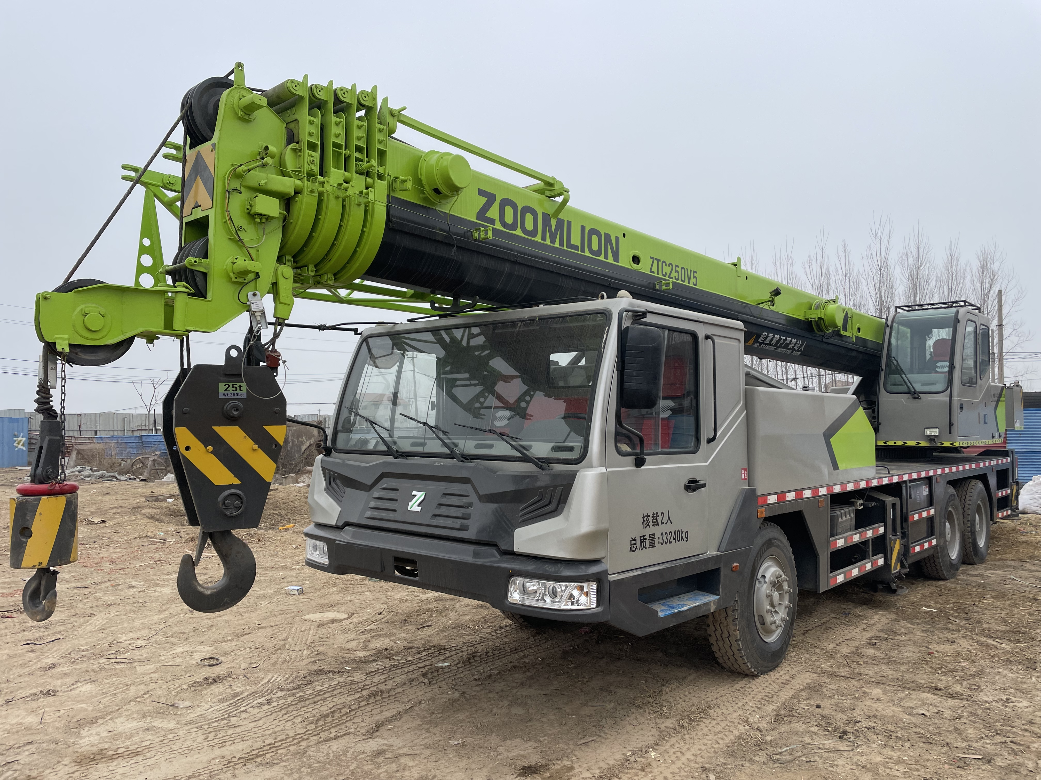

More XCMG Models...
More Zoomlion Models...
More Sany Models...
Zoomlion 500 ton
Model: QAY500
Zoomlion 400 ton
Model: QAY400
Sany 80 ton
Model: STC800S
XCMG 500 ton
Model: QAY500K/XCA500
XCMG 260 ton
Model: QAY260/XCA260
XCMG 240 ton
Model: QAY240/XCA240
XCMG 130 ton
Model: QY130K
XCMG 90 ton
Model: QY90K
XCMG 80 ton
Model: XCT80
XCMG 85 ton
Model: QY85KA
XCMG 130 ton
Model: QY100K
Sany 50 ton
Model: STC500
Sany 25 ton
Model: STC250H
Truck Crane/All-Terrain Crane (25 ton-1600 ton)
XCMG 70 ton
Model: QY70K
Zoomlion 110 ton
Model: QY110/ZTC1100V
Zoomlion 80 ton
Model: QY80/ZTC800V
Zoomlion 55 ton
Model: QY55/ZTC550V
Zoomlion 30 ton
Model: QY30/ZTC300V
Zoomlion 25 ton
Model: QY25/ZTC250
03
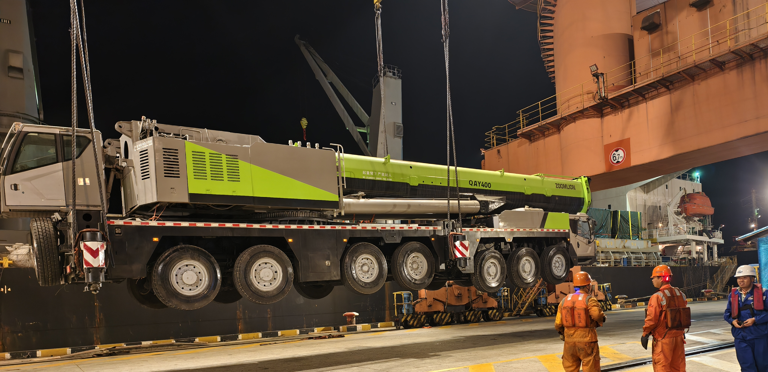
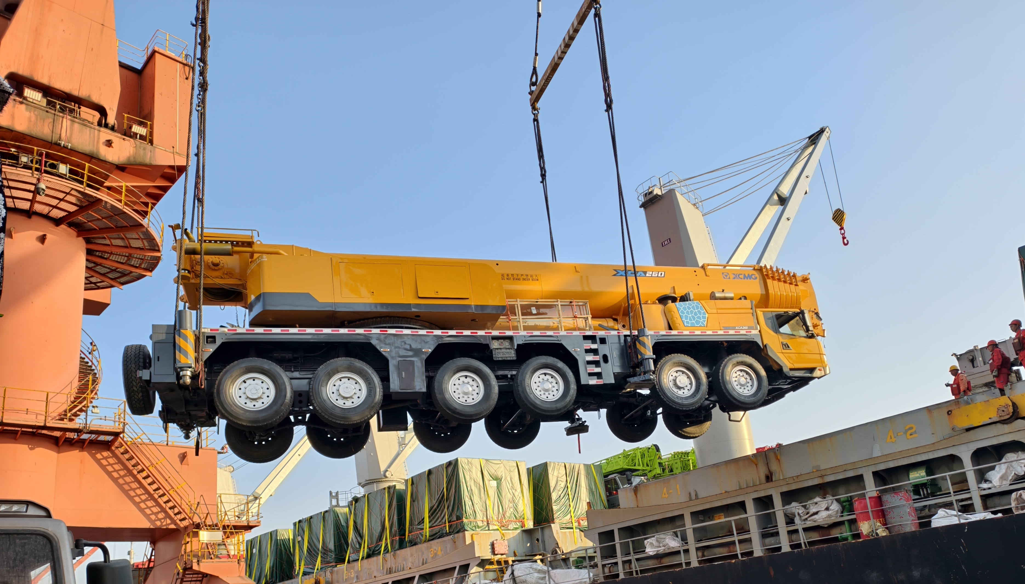
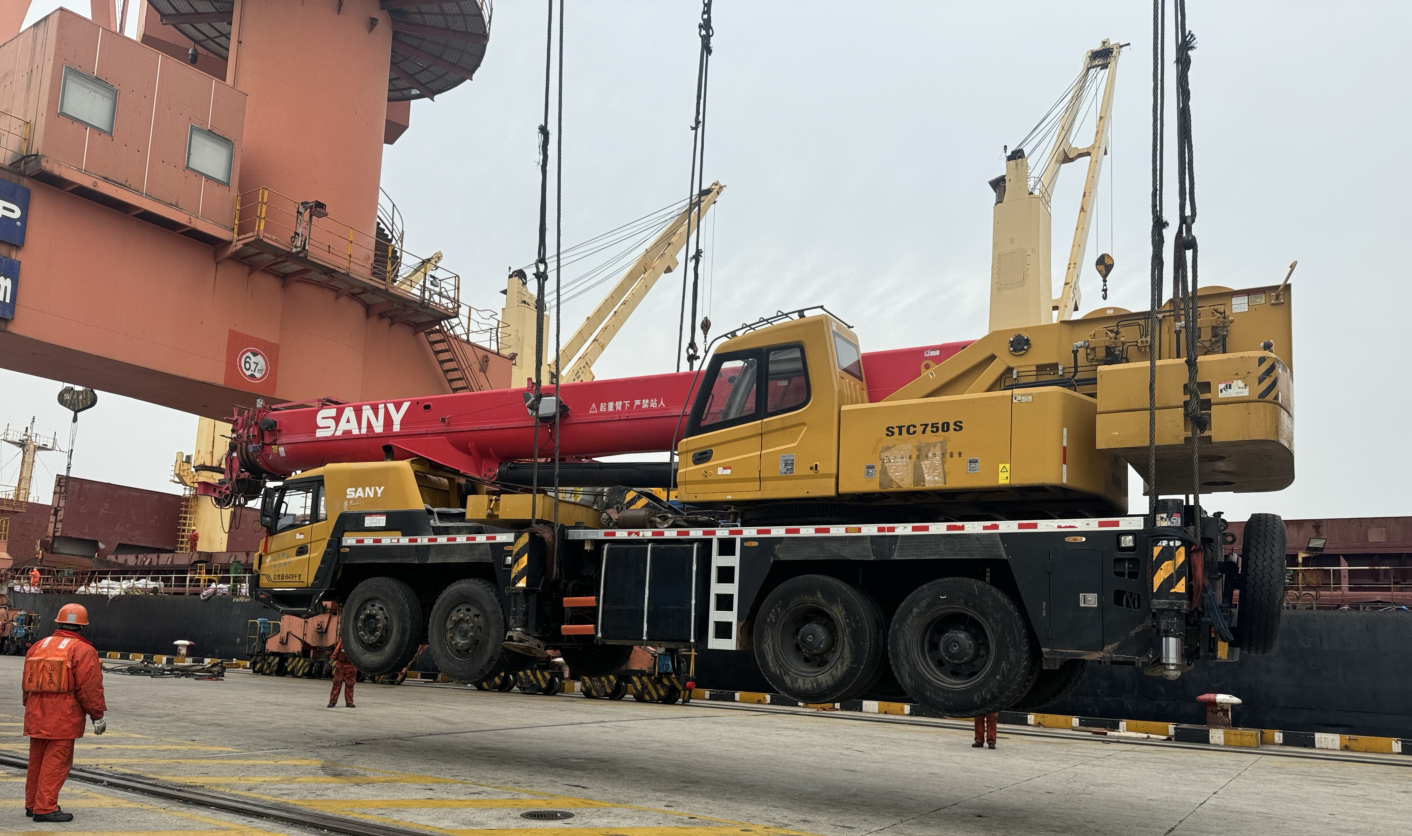
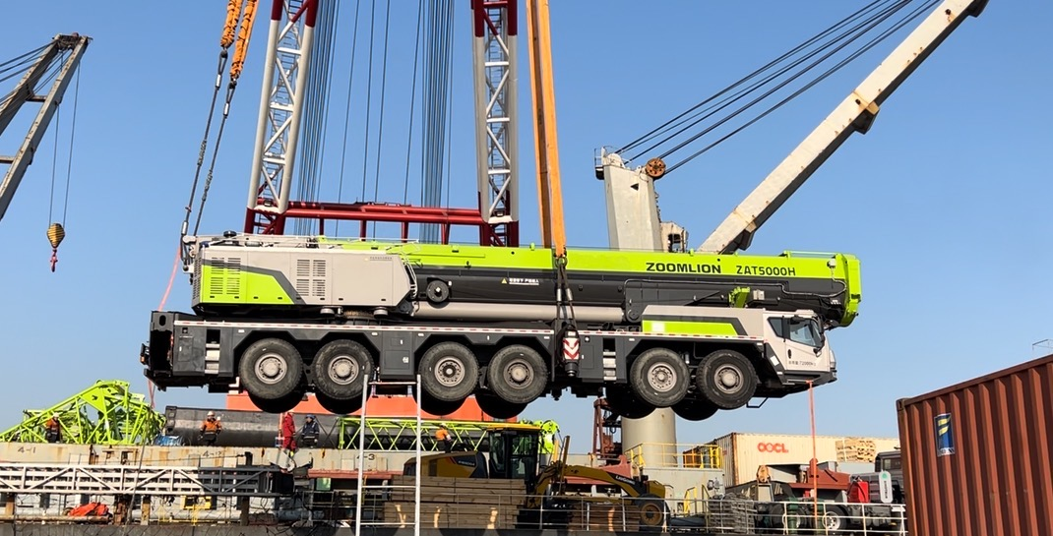
CONTACT US

Tel

